New Marking Scale

S6/S7 Mathematics 3 and 5 Period

The exemplars below illustrate the procedures outlined in the Matrix Manual Mathematics, which accompanies this document. Please note that the approach is the same for both the 3P and 5P mathematics course. It is recommended that the manual is read prior to viewing these documents.

# **Generic Matrices**

The original Excel spreadsheets for these matrices are available for use. Please refer to the communications received from the mathematics inspector.

## Generic MA 3P Matrix

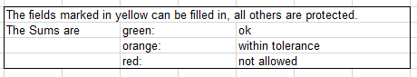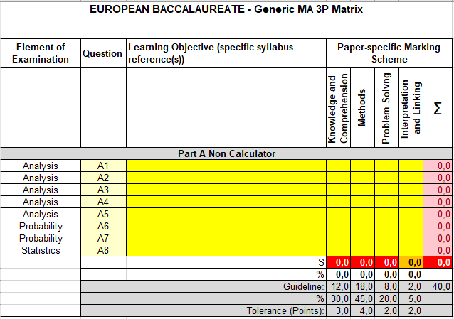



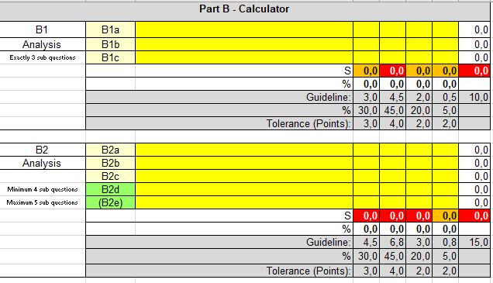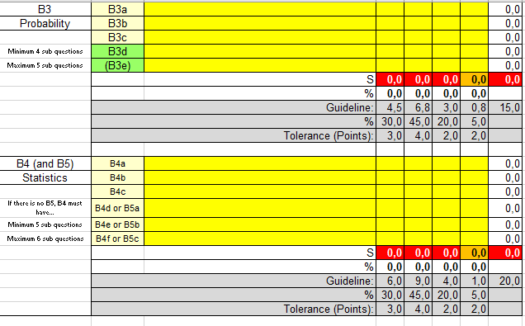

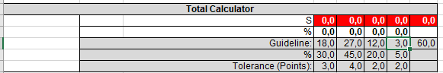

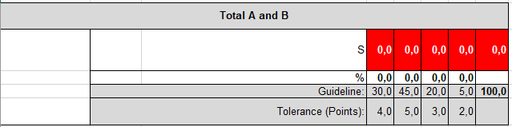

## 1.2. Generic MA 5P Matrix

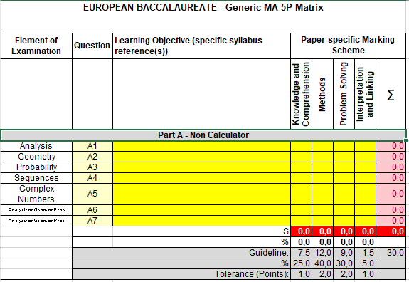

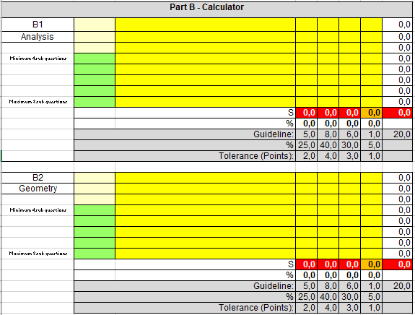

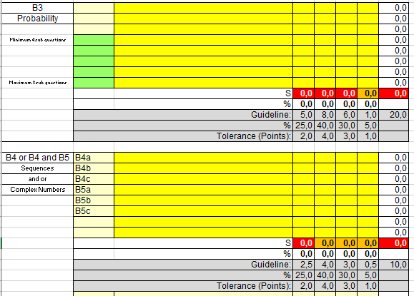

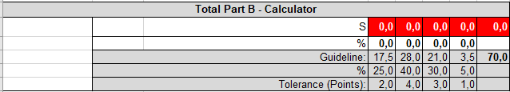

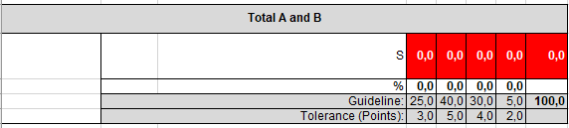

1. Paper-specific Matrices

These matrices use the 2019 Baccalaureate papers to illustrate the procedures laid out in the Matrix Manual Mathematics, which accompanies this document.

## 2.1. MA 3P (Based on the Baccalaureate of 11th June 2019)

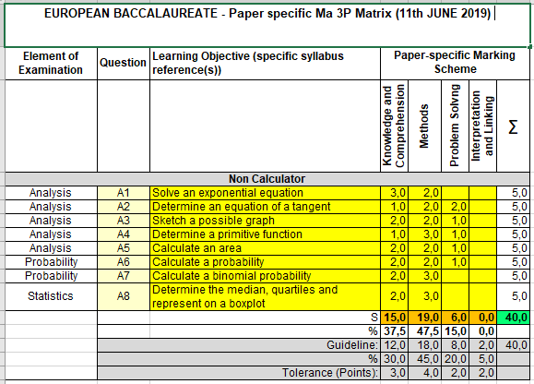

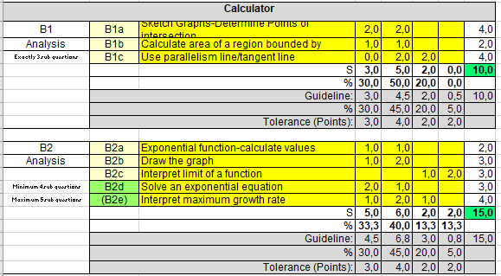

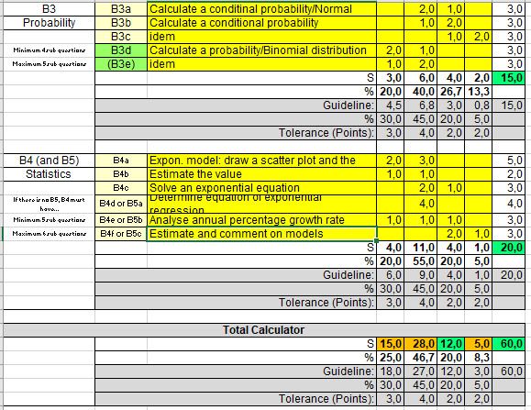

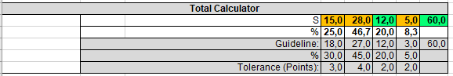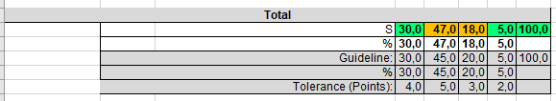

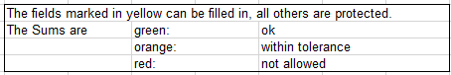

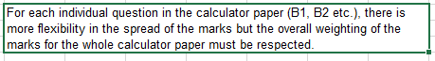

## 2.2. MA 5P (Based on the Baccalaureate of 11th June 2019)

## 

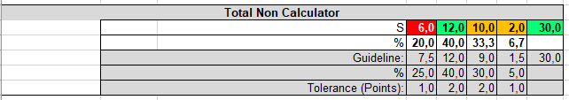

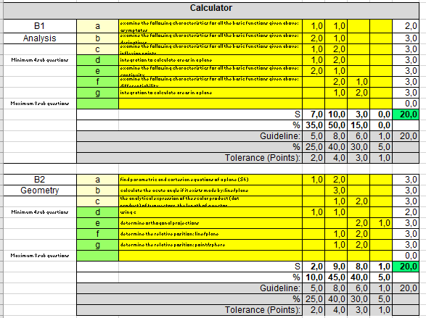

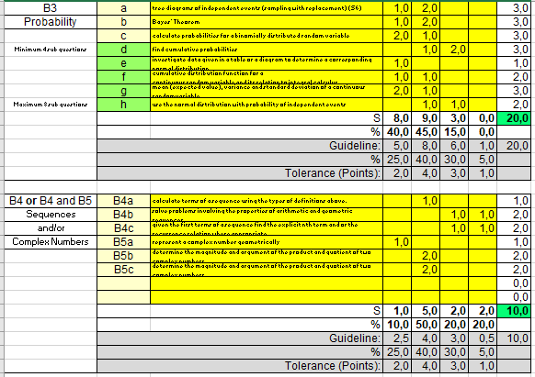

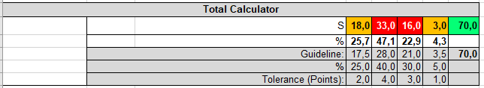

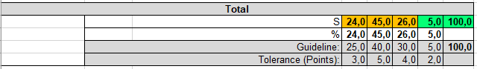

# **3.Sample Bac written examination**

## **For reference the MA-3P 11th June 2019 paper is included here. The same approach can be applied to past BAC Exams for 3P and 5P.**

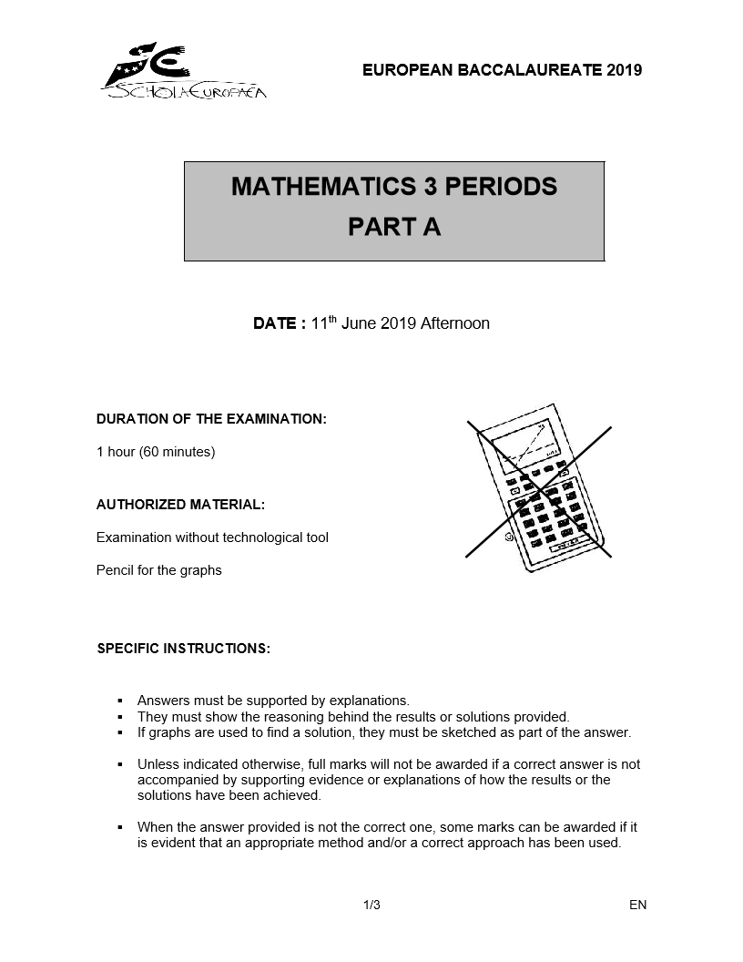

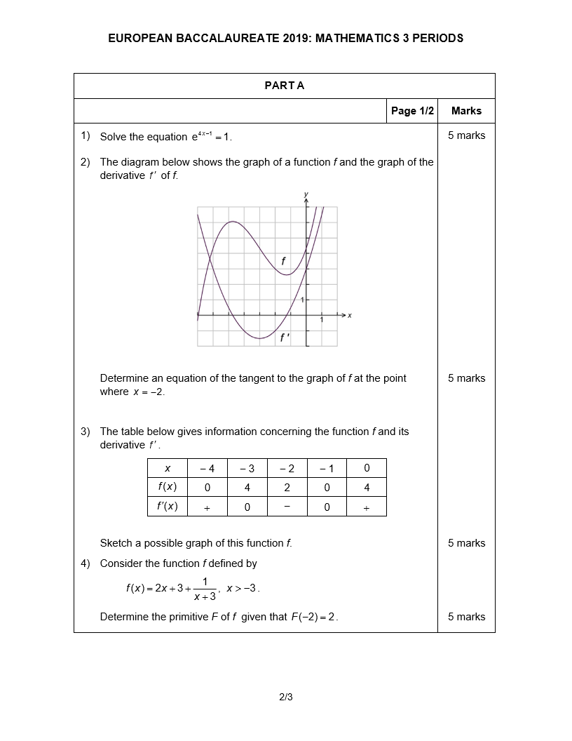

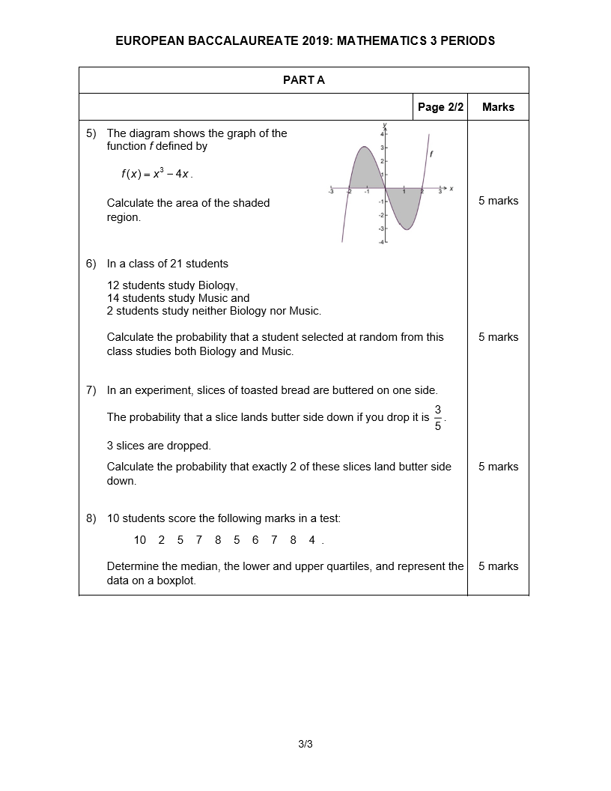

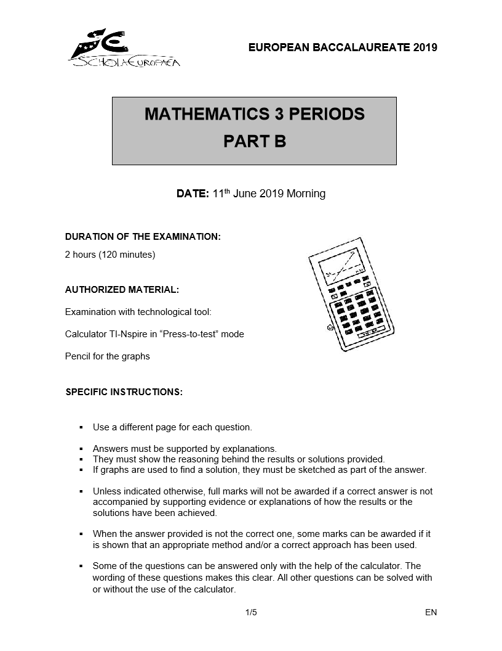

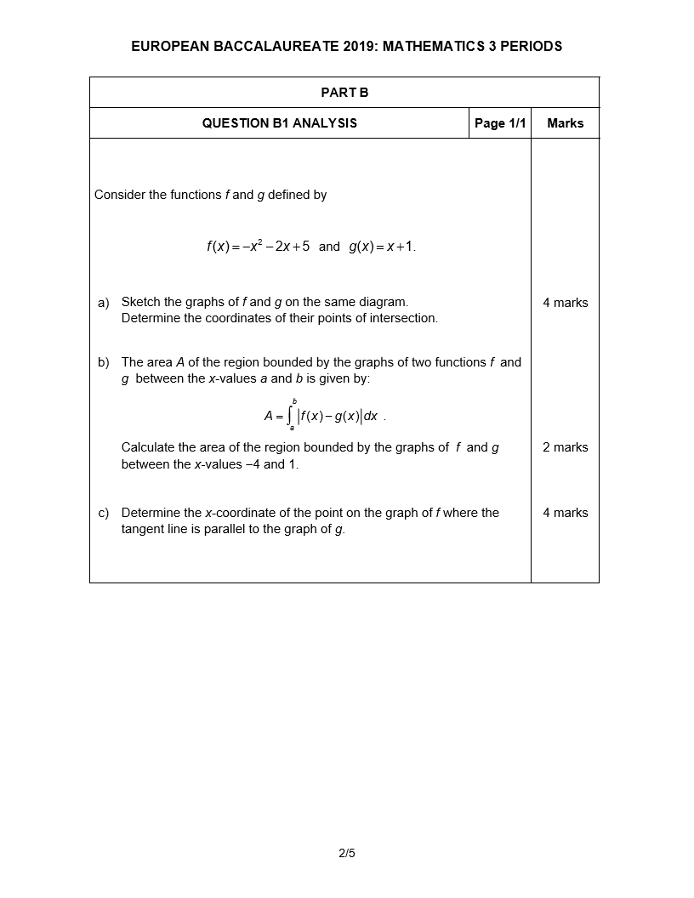

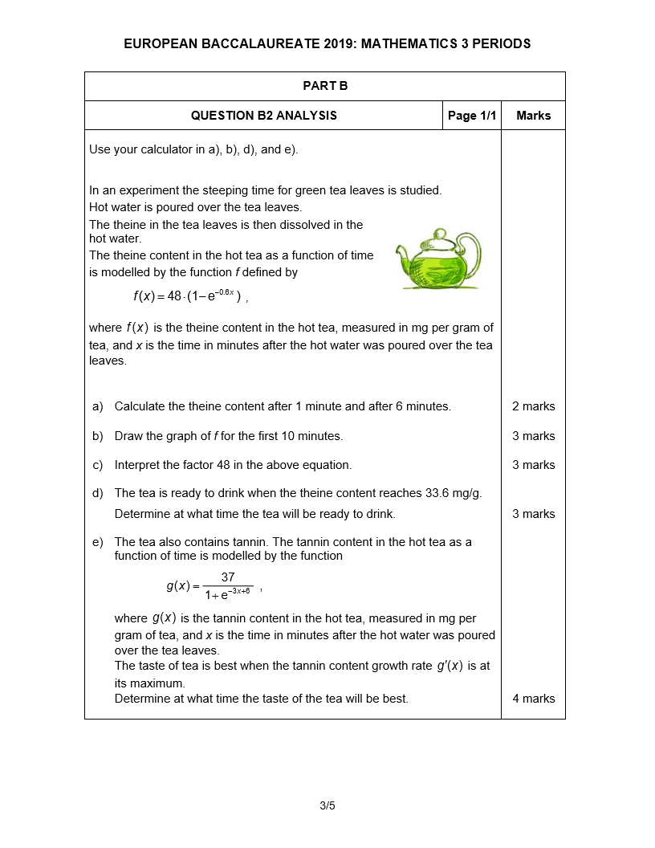

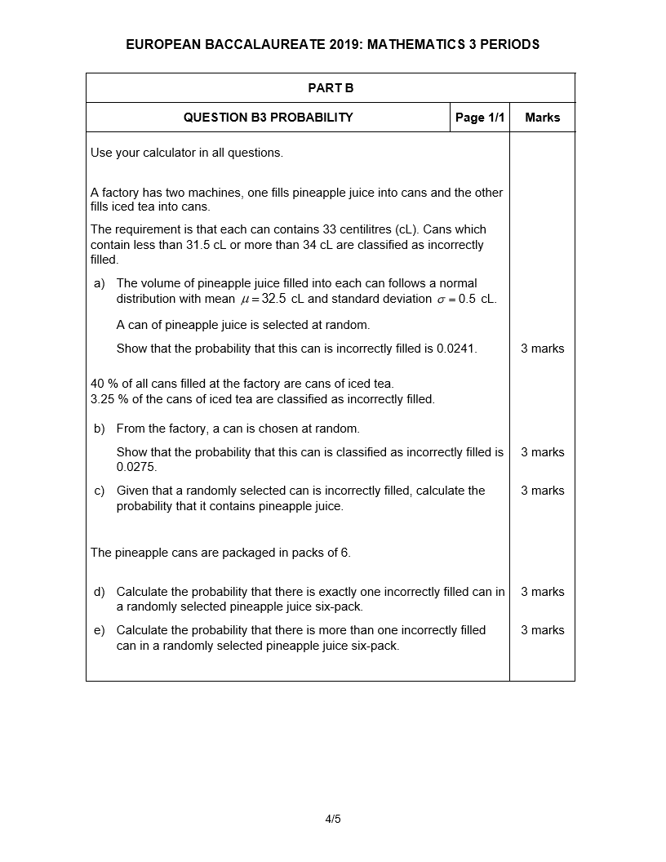

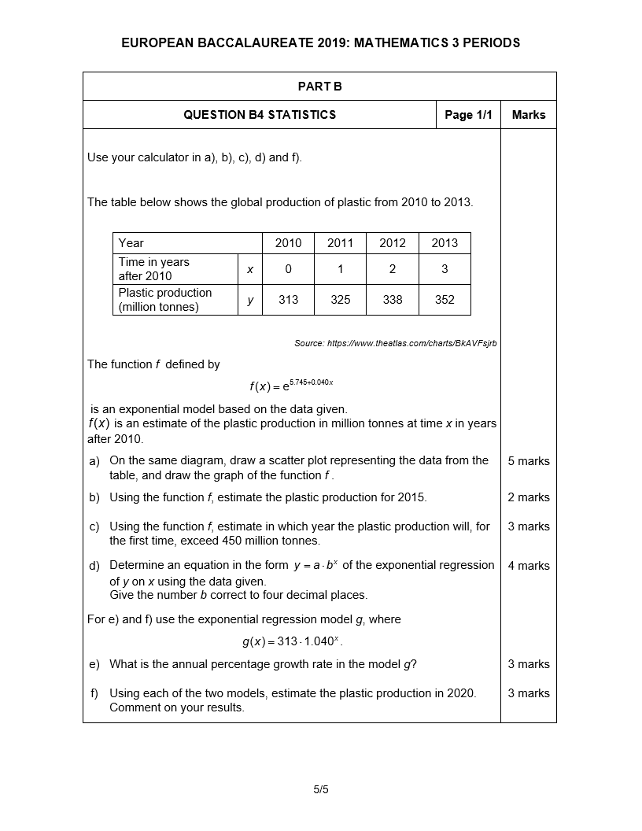

# **Marking scheme**

## Below is an example of a marking scheme linked to the maths matrix. The 3p paper has been used to illustrate the formatting. For brevity, the 5p mark scheme has been omitted as, given the common approach being adopted for the 3p and 5p course, it would follow the same structure as the example below.

|  |  |  |  |  |  |  |  |  |  |  |  |  |  |  |  |
| --- | --- | --- | --- | --- | --- | --- | --- | --- | --- | --- | --- | --- | --- | --- | --- |
| **Questions Part A (3P) - 2019** | | |  | | |  | |  | |  | |  | | |  |
| 1.Knowledge and Comprehension  2.Methods  3. Problem Solving  4. Interpretation and Linking | | 1. | | | 2. | | 3. | | 4. | | Σ | | | **Learning Objectives/ Tasks** | |
| **A1** |  | | |  | | |  | |  | |  | | Analysis | | |
|  |  | | |  | | |  | |  | | 5 | | **Exponen-tial equation** | | |
| $4x-1$ = 0  solution $x=\frac{1}{4}$ | 3 | | | 2 | | |  | |  | |  | | **S7: Define** the exponential function   |  |  | | --- | --- | | **S2**: **Solve** an equation | | |  | | | |
| **A2** |  | | |  | | |  | |  | |  | | Analysis | | |
| |  | | --- | | The diagram below shows the graph of a function *f* and the  graph of the derivative  of *f*.    Determine an equation of the tangent to the graph of *f* at the point where | |  | | |  | | |  | |  | | 5 | | **Graph of a function and its derivative** | | |
| The tangent line to the graph of *f* in its point having *x*-coordinate equal to $-2$ has equation $y-f\left(-2\right)=f^{'}\left(-2\right)\left(x+2\right).$ $f\left(-2\right)=3$ $f^{'}\left(-2\right)=-1$ $y-3=-(x+2)$      i.e. $y=-x+1$ OR: $f^{'}\left(-2\right)=-1$ $y=-1x+c$ $f\left(-2\right)=3$ $y=-x+1$      *For a solution using the graph of f only, award maximum 3 p*  solution $x=\frac{1}{4}$ | 1  1 | | | 2  2 | | | 2  2 | |  | |  | | S6:  **Know** the formulae for a tangent to the graph  **Apply**/ **use** the graphs  **Solve (Calculate and reduce)**  **Use** the graph  **Apply** a formula of tangent  **Solve**   |  | | --- | |  | | | |
| **A3** |  | | |  | | |  | |  | |  | | Analysis | | |
| The table below gives information concerning the function *f* and its derivative .   |  |  |  |  |  |  | | --- | --- | --- | --- | --- | --- | | *x* | − 4 | − 3 | − 2 | − 1 | 0 | |  | 0 | 4 | 2 | 0 | 4 | |  |  | 0 | − | 0 |  |   Sketch a possible graph of this function *f*. |  | | |  | | |  | |  | | 5 | | **Show understan-ding** of a function and its derivative | | |
| For instance: | 1 | | | 3 | | | 1 | |  | |  | | **S6: Show understand-ding** of …  **Sketch** a possible graph   |  | | --- | |  |  |  | | --- | |  | | | |
| **A4** |  | | |  | | |  | |  | |  | | Analysis | | |
| Consider the function *f* defined by  , .  Determine the primitive *F* of *f* given that . |  | | |  | | |  | |  | | 5 | |  | | |
| For $x>-3$ we have: $\int{f\left(x\right) dx}=x^{2}+3x+\ln{(x+3)}+k$   Using $F\left(-2\right)=2$ ${(-2)}^{2}+3∙\left(-2\right)+\ln{1}+k=2$ $4-6+k=2$ , from which we get $k=4$.  The function *F* may thus be expressed by $F(x)= x^{2}+3x+\ln{(x+3)}+4$ | 2 | | | 2 | | | 1 | |  | |  | | **S7: Determine** a primitive   |  |  | | --- | --- | | **Apply** a condition  **Determine** the primitive given that .… | | |  | | | |
| **A5** |  | | |  | | |  | |  | |  | | Analysis | | |
| The diagram shows the graph of the  function *f* defined by  .     |  | | --- | | Calculate the area of the shaded region. | |  | | |  | | |  | |  | | 5 | | **Area under the graph** | | |
| The graph intersects the *x*-axis at $x=-2$, $x=0$, $x=2.$ The area *A* of the shaded region is given by    since the graph is symmetrical with respect to the origin. $A=2\int_{-2}^{0}{\left(x^{3}-4x\right)dx}=2∙{\left[\frac{x^{4}}{4}-2x^{2}\right]}_{-2}^{0}=8$ | 2 | | | 2 | | | 1 | |  | |  | | **S7:**  **Define** the area under the graph  **Recognize**  **Determine** the integral  **Interpret**   |  | | --- | |  | | | |

|  |  |  |  |  |  |  |  |  |  |  |  |  |
| --- | --- | --- | --- | --- | --- | --- | --- | --- | --- | --- | --- | --- |
| **A6** | | |  | |  | |  | |  | |  | Probability |
| In a class of 21 students  12 study Biology,  14 study Music and  2 study neither Biology nor Music.  Calculate the probability that a student selected at random from this class studies both Biology and Music. | | |  | |  | |  | |  | | 5 | **Elemen-tary probability** |
| There are 19 students who take biology and/or music.  Therefore, there are $14+12-19=7$ who take both biology and music. $P\left(student takes biology and music\right)=\frac{7}{21} =\frac{1}{3}$ . | | | 2 | | 2 | | 1 | |  | |  | S7: Probability  **Analyse** and **explain**  **Calculate** a probability |
| **A7** | | |  | |  | |  | |  | |  | Probability |
| In an experiment, slices of toasted bread are buttered on one side.  The probability that a slice lands butter side down if you drop it is .  3 slices are dropped.  Calculate the probability that exactly 2 of these slices land butter side down. | | |  | |  | |  | |  | | 5 | **Binomial distri-bution** |
|  | | | 2 | | 3 | |  | |  | |  | **Recognize** binomial parame-ters |
| **A8** | | |  | |  | |  | |  | |  | Statistics |
| 10 students score the following marks in a test:  10 2 5 7 8 5 6 7 8 4 .  Determine the median, the lower and upper quartiles, and represent the data on a boxplot. | | |  | |  | |  | |  | | 5 | **Elemen-tary statistics** |
| |  |  |  |  |  |  |  |  |  |  |  | | --- | --- | --- | --- | --- | --- | --- | --- | --- | --- | --- | | Rearranging data: | 2 | 4 | 5 | 5 | 6 | 7 | 7 | 8 | 8 | 10 |   Median is $6.5$, lower quartile is 5, upper quartile is 8    Boxplot | | 2 | 3 | |  | |  | |  | | S7:  **Determine** the median, the quartiles and **represent** on a boxplot | | | |

|  |  |  |  |  |  |  |
| --- | --- | --- | --- | --- | --- | --- |
| **Questions Part B (3P) - 2019** |  |  |  |  |  |  |
| 1. Knowledge and Comprehension  2. Methods  3. Problem Solving  4. Interpretation and Linking | 1. | 2. | 3. | 4. | Σ | **Learning Objectives/ Tasks** |
| **B1** |  |  |  |  |  | **Analysis** |
| 4 marks  2 marks  4 marks |  |  |  |  | 10 | **S6/S7:** *Revisiting linear and quadratic models*  *Area of the region bounded by two graphs and between x-values* |
|  | 2  1 | 2  1 |  |  |  | **Sketch** the graphs  **Determine** the coordinates of points of intersection  **Calculate** the area of the region bounded by two graphs and between two x-values |
|  |  | 2 | 2 |  |  | |  | | --- | | **Determine** the x-coord. |   **Explore** the relationship between graphs/derivat. **Characterize** the parallelism of two lines   |  | | --- | |  | |

|  |  |  |  |  |  |  |
| --- | --- | --- | --- | --- | --- | --- |
| **B2** |  |  |  |  |  | **Analysis** |
|  |  |  |  |  | 15 | **S7:** *Exponential functions* |
|  | 1  1  2  1 | 1  2  1  2 | 1  1 | 2 |  | **Calculate** the y-value  **Draw** the graph  **Calculate** a limit/**Interpret** a factor  **Solve** an equation  **Calculate** the derivative  **Explore** the derivative and how it may vary  **Solve** an equation   |  | | --- | |  | |

|  |  |  |  |  |  |  |  |  |  |  |  |  |  |
| --- | --- | --- | --- | --- | --- | --- | --- | --- | --- | --- | --- | --- | --- |
| **B3** | |  | |  | |  | |  | |  | | **Probability** | |
|  | |  | |  | |  | |  | | 15 | | **S6:***General probability rules, Dependent events, Conditional probabilities*  **S7:***Normal distribution* | |
|  | | 2  1 | | 2  1  1  2 | | 1  2  1 | | 2 | |  | | **Calculate** a probability  (normal distribution  **Know** the rules for a conditional probability  **Investigate, connect** and **apply**  **Calculate** probabilities for a random variable with a binomial distribution  Id.   |  | | --- | |  |  |  |  | | --- | --- | |  |  | | |
| **B4** | |  | |  | |  | |  | |  | | **Statistics** | |
|  | |  | |  | |  | |  | | 20 | | **S7:***Visualization, Correlation, Regression* | |
|  | | 2  1  1 | | 3  1  2  4  1 | | 1  1  2 | | 1 | |  | | **Draw** a scatter plot/graph   |  | | --- | | **Estimate** a value  **Apply** and **estimate**  **Determine** an equation of the exponential regression  **Use** a  regression model  **Interpret**  **Analyse** and **comment** on results | | |