# LogoBWMatrix Manual Mathematics

# Brief guidance for good practice

## Preamble

This document builds upon the *Reference Document 2017-05-D-29-en-8* defining *7 levels for the marking scale* and *a threshold for “sufficient” that is set at 50/100 points*. Part 5 of the *Reference Document* provides the general assessment tools which are available for the evaluation process.

The aim of this manual is to promote a common approach among teachers on how to develop a consistent and balanced assessment in mathematics. The framework is given by a *test matrix* which defines how a test should be conceived. The matrix specifies the learning objectives, the skills and subject specific facts, the kind of knowledge to be demonstrated, the tasks that must be accomplished as well as the weight awarded to the questions/tasks. This weighting also ensures that the final mark is in line with the 7 levels of the marking scale in the reference document. In addition, the construction of a matrix makes it easy to check that the various content areas are covered by the test/exam.

This document, together with the preamble to the syllabus, *2010-D-441-en-5,* defines the structure and content of the BAC paper in mathematics.

Complete matrices based on the questions of the written BAC 2019 (Math 3P and 5P) are attached to this document. These are contained in a single document as the approach is the same for both the 3P and 5P courses.

*Students (3P) are assessed in the following subject areas: Analysis, Probability, Statistics*

*Students (5P) are assessed in Analysis, Geometry (2D and 3D), Probability, Sequences and Complex Numbers.*

In order to operationalise the mathematical competences to aid the construction of tests, it is valuable to organise the skills into larger classes of competency. The *four competency classes* are:

* Knowledge and comprehension,
* Methods,
* Problem solving,
* Interpretation and linking.

We have broken down the Analysis heading mentioned in the reference document into two parts in order to be able to assess the level of students across the ability range.

## The levels of difficulty

*Assessment design* relates to tasks that reflect the *complexity of mathematical thinking*.

Level 1.  *Recall*: Tasks at this level require recall of facts or rote application of simple procedures. The task does not require any cognitive effort beyond remembering the right response or formula.

Level 2.  *Inference*: At this level, tasks require some choice of approach and straightforward reasoning in response to a familiar-looking situation or problem. Tasks with more than one mental step are usually level 2.

Level 3. *Strategic Thinking*: At this level of complexity, tasks require planning and abstract thinking. A task with multiple valid approaches or non-routine problems would be level 3.

Level 4. *Extended Thinking*: Tasks at this level require the ability to synthesize or extend knowledge, possibly from different areas of the subject, and to justify the chosen approach, methods and results, in order to solve problems involving unfamiliar concepts or theorems.

## Assessing the different competences

*Knowledge and comprehension:* This competence will mainly be assessed with questions at level 1 of difficulty.

*Methods:* This competence will mainly be assessed with questions at level 2 of difficulty.

*Problem solving:* This competence will mainly be assessed with questions at level 2 and 3 of difficulty.

*Interpretation and linking:* This competence will mainly be assessed with questions at level 3 and 4 of difficulty.

*Communication:* This competence will be assessed globally at all levels of difficulty, based on correct mathematical notation, structure of working and clarity of explanation.

## Weighting the competences

As written in the reference document *2017-05-D-29-en-8,* the percentage weighting of the competences shows the relative importance/value being attributed to the competence in focus.

The table below shows the percentages assigned to the written exams of the baccalaureate in 3 Period and 5 Period Mathematics:

**Math 3P**

|  |  |  |  |  |
| --- | --- | --- | --- | --- |
| **Competences** | **%** | **Total marks** | **PART A (without calculator)**  **Guideline marks** | **PART B (with calculator)**  **Guideline marks** |
| Knowledge and comprehension | 30% | 30 | 12 | 18 |
| Methods | 45% | 45 | 18 | 27 |
| Problem solving | 20% | 20 | 8 | 12 |
| Interpretation and linking | 5% | 5 | 2 | 3 |

**Math 5P**

|  |  |  |  |  |
| --- | --- | --- | --- | --- |
| **Competencies** | **%** | **Total marks** | **PART A (without calculator)**  **Guideline marks** | **PART B (with calculator)**  **Guideline marks** |
| Knowledge and comprehension | 25% | 25 | 7 | 18 |
| Methods | 40% | 40 | 12 | 28 |
| Problem solving | 30% | 30 | 9 | 21 |
| Interpretation and linking | 5% | 5 | 2 | 3 |

## The construction of the test matrix

The following steps will facilitate the construction of a paper specific matrix. Please note that there is a common approach for the 3P- and 5P course. Although the steps use a 3P paper as an exemplar the steps will be identical for a 5P paper.

**Step 1:**

Create the table underneath before starting to write questions. It gives an overview. Use a spread sheet like EXCEL to facilitate the modification of the values later if necessary. Preformatted spreadsheets are available for the Ma3 and Ma5 Baccalaureate (Generic matrices MA 3P and MA 5P).

Please note that this tool can also be used as a marking instrument – for example for grading investigations, oral examinations etc. The percentage weightings will have to be adjusted accordingly.

The example below shows an extract of the table for the BAC-MATH 3P Part A (non calculator).

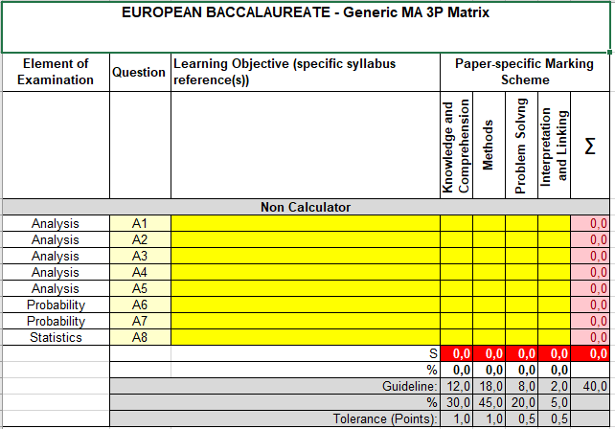

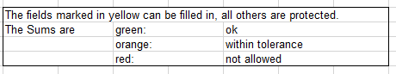

**Step 2:**

Start writing the exam questions and solutions. The solutions will be filled into a second table underneath together with the learning objectives/tasks, the competences and the weighting of competences. This then also becomes the mark scheme accompanying the assessment.

In the first place, the highest level of thinking for a question should be identified. This is the starting point for allocating marks over one, two or three levels in a given question. In effect you are identifying the **main** competences being assessed and this links to the difficulty of the question. Spreading the marks allows easier differentiation between, say, an easy and a hard problem solving question.

Having a summary of the levels of competencies for each question, allows you to get an impression of the degree of difficulty of each part and ensures that each strand of the syllabus has a spread of difficulty in the assessment. However, there is more flexibility in the weighting per question than for the weighting of an overall competence.

This allows a detailed distribution of the marks according to what is assessed.

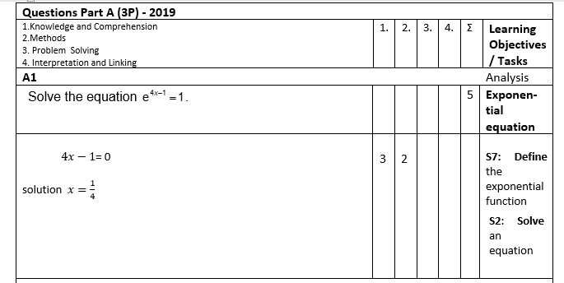

**Step 3:**

Copy the marks from the second table and paste them into the first one which is the overview.

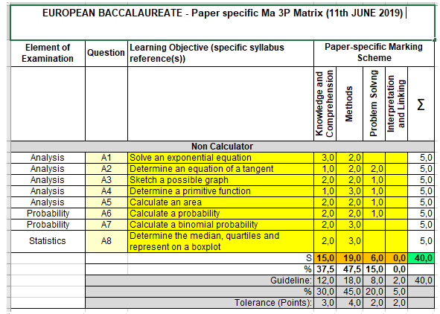

**Step 4:**

Using this Paper specific Matrix, check now if:

1. The correct totals for each part have been met, as well as the correct overall total.
2. The allocated points match the weightings. This is less important on a per question basis, but there should be a reasonable spread of ability per long question. It is more important for each part of the exam (calculator/non-calculator) and it is critical for the overall exam. So, there may be difficult and easy questions within each paper, and one paper may be slightly more or less easy than the other, but the overall balance of both papers must meet the weightings. Adjust your questions until this balance is met.

**Step 5:**

Check that a suitable variety of learning objectives have been met. Make sure that there is not repeated assessment of the same topic.

## The current situation

Please note that, as the NMS is arriving ahead of the transition to the new mathematics syllabus, the working group has used the 2019 Bac papers as an example to provide a familiar reference point that reflects the syllabus and structure that will be used in the upcoming Bac cycle.

However, to model the target weightings of the NMS outlined in this document more weight than was merited by the 2019 Bac has been given to problem solving and interpretation. The expectation is that the weighting of competences outlined in this document will be more accurately reflected in the 2021 Bac papers.

As the approach outlined above is based on the principles given in the guidelines for the marking system of the European schools, it is applicable beyond S6 and S7.

## The S5 harmonized exams

The main ideas developed in this paper, focused on a competency matrix and an assessment construction, easily translate to the S5 harmonized exams.

The global percentage rates of the competency classes should be as follows:  
  
**S5 P4:**

Knowledge and comprehension 30%, Processes 45%, Problem solving 20% and Interpretation and linking 5%.  
  
**S5 P6:**

Knowledge and comprehension 25%, Processes 40%, Problem solving 30% and Interpretation and linking 5%.

Using a common matrix means that the S5 harmonized exams, although different in different European schools, can be shown to be of comparable difficulty.

## Verbs as Test-making facilitators

Although depending on the situation and context, the verbs highlighted in the new syllabuses and built into the competences, can be a guide in classifying the degree of difficulty of a question.

The table below gives a non-exhaustive list of verbs:

|  |  |
| --- | --- |
| **Task Complexity** | **Key Vocabulary (non-exhaustive list)** |
| Knowledge and comprehension | Compare, convert, define, determine, know, name, order, recall, recognise, round, simplify, understand, verify |
| Methods | Apply, calculate, construct, draw, illustrate, organise, plot, show, simplify, sketch, solve, use |
| Problem solving | Analyse, classify, estimate, explain, model, represent |
| Interpretation and linking | Comment, interpret, investigate, model, connect, justify. |

## Closing Statement

Clearly any major changes within a system will require reviewing on a regular basis. Thus, this document is dynamic and will be revised and further developed over time.

________

Annexes:

NMS_ Mathematics_ EN

The Generic Matrices MA 3P and MA 5P (Excel sheets)