**Generic Matrix for Written Exam LATIN Baccalaureate (EN version)**

| **Task** | **Competences** | **Learning Objective**  *The student is able to ..*. | **Question(s)** | **Evaluation Marking** | **Weight in points** | **Weight of final mark in %** |
| --- | --- | --- | --- | --- | --- | --- |
| **PART I**  **30 points**  **Comprehension of an unseen text** | Understanding of a short **non-literary** text | Independent translation | **I. a) non-literary** text | Marking Scheme/Rubric | 6/30 | 6% |
| A/ Understanding the meaning of a **literary** text  B/ Identify the syntactical structures of the text  C/ Establish a text which  * respects normal standards of spelling, syntax and expression,  * respects the register of the text | Independent translation | **I. b) literary** text | Marking Scheme/Rubric | 24/30 | 24% |
|  | **Total of assessment of part I** |  |  |  | **30/30** | **30%** |  |  |
| **PART II**  **40 points**  **Comprehension of set Latin texts read in class** | A/ Analyse one or more grammatical forms | Show knowledge of morphological and grammatical structures | **II. 1. a)** | Marking Scheme/Rubric | 5/40 | 5% |
| B/ Analyse lexical forms using their etymology | Show an advanced knowledge of vocabulary and etymology | **II. 1. b)** | Marking Scheme/Rubric | 5/40 | 5% |
| C/ Critical analysis of the sense and form of a literary text | Write a critical analysis of a text exploring its explicit and implicit meanings | **II. 2** | Marking Scheme/Rubric | 20/40 | 20% |
| D/ Comparison of translations | Compare translations and make a critical judgement | **II. 3** | Marking Scheme/Rubric | 10/40 | 10% |
|  | **Total of assessment of part II** |  |  |  | **40/40** | **40%** |
| **PART III**  **30 points**  **Essay** | A/ Establish a text in response to the question posed | Show an advanced knowledge of the ancient Roman world | **III** | Marking Scheme/Rubric | 3/30 | 3% |
| B/ Show knowledge of the set texts and themes of the programme | Show in a precise and balanced way an appreciation of the reception of the Classical world in its different dimensions | **III** | Marking Scheme/Rubric | 15/30 | 15% |
| C/ Express a personal opinion within a coherent argument | Use the culture of the ancient world to construct a personal reflection including political, philosophical and aesthetic elements | **III** | Marking Scheme/Rubric | 7,5/30 | 7,5% |
| D/ Write a correct and controlled text | Respect normal standards of spelling, syntax and expression | **III** | Marking Scheme/Rubric | 4,5/30 | 4,5% |
| **Total of assessment of part III** |  |  |  | **30/30** | **30%** |
| **TOTAL** |  |  |  |  | **100**  **(30+40+30)** | **100%** |

|  |  |  |  |  |  |  |  |
| --- | --- | --- | --- | --- | --- | --- | --- |
| EXCELLENT | VERY GOOD | GOOD | SATISFACTORY | SUFFICIENT |  | WEAK | VERY WEAK |
| 100-90 | **89-80** | **79-70** | **69-60** | **59-50** |  | **49-21** | **20-0** |

**Paper specific Matrix for the Written exam LATIN Baccalaureate (EN version)**

|  | **Task** | **Competences** | **Learning Objective**  *The student is able to ..*. | **Question(s)** | **Evaluation Marking** | **Weight in points** | **Weight of final mark in %** |
| --- | --- | --- | --- | --- | --- | --- | --- |
| **PART I**  **30 points** | **Comprehension of an unseen text** | Understanding of a short **non-literary** text | Independent translation | **I. a) non-literary** text | 6 points  > 4 points: establishing the overall sense  > 2 points: quality of expression | 6/30 | 6% |
|  | A/ Understanding the meaning of a **literary** text  B/ Identify the syntactical structures of the text  C/ Establish a text which  * respects normal standards of spelling, syntax and expression,  * respects the register of the text | Independent translation | **I. b) literary** text | 24 points  > A/: 10 points  > B/: 10 points  > C/: 4 points | 24/30 | 24% |
| **Total of assessment of part I** |  |  |  |  | **30/30** | **30%** |
| **PART II**  **40 points** | **Comprehension of set Latin texts read in class** | A/ Analyse one or more grammatical forms | Show knowledge of morphological and grammatical structures | **II. 1. a)** | 5 points | 5/40 | 5% |
|  | B/ Analyse lexical forms using their etymology | Show an advanced knowledge of vocabulary and etymology | **II. 1. b)** | 5 points | 5/40 | 5% |
|  | C/ Critical analysis of the sense and form of a literary text | Write a critical analysis of a text exploring its explicit and implicit meanings | **II. 2** | 20 points | 20/40 | 20% |
|  | D/ Comparison of translations | Compare translations and make a critical judgement | **II. 3** | 10 points | 10/40 | 10% |
| **Total of assessment of part II** |  |  |  |  | **40/40** | **40%** |
| **PART III**  **30 points** | **Essay** | A/ Establish a text in response to the question posed | Show an advanced knowledge of the ancient Roman world | **III** | 3 points | 3/30 | 3% |
|  | B/ Show knowledge of the set texts and themes of the programme | Show in a precise and balanced way an appreciation of the reception of the Classical world in its different dimensions | **III** | 15 points | 15/30 | 15% |
|  | C/ Express a personal opinion within a coherent argument | Use the culture of the ancient world to construct a personal reflection including political, philosophical and aesthetic elements | **III** | 7,5 points | 7,5/30 | 7,5% |
|  | D/ Write a correct and controlled text | Respect normal standards of spelling, syntax and expression | **III** | 4,5 points | 4,5/30 | 4,5% |
| **Total of assessment of part III** |  |  |  |  | **30/30** | **30%** |
|  | **TOTAL** |  |  |  |  | **100** | **100%** |

|  |  |  |  |  |  |  |  |
| --- | --- | --- | --- | --- | --- | --- | --- |
| EXCELLENT | VERY GOOD | GOOD | SATISFACTORY | SUFFICIENT |  | WEAK | VERY WEAK |
| 100-90 | **89-80** | **79-70** | **69-60** | **59-50** |  | **49-21** | **20-0** |



**BACCALAUREATUS EUROPAEUS MMXXI**

**LINGUA LATINA**

**DATE: …/../ 2021**

**LENGTH OF THE EXAMINATION: 3 HOURS (180 minutes)**

**PERMITTED EQUIPMENT: DICTIONARY**

**CONSPECTUS GRAMMATICALIS**

**SPECIAL REMARKS: ANSWER PARTS I, II and III**

1. **(30 points) READING SKILLS: UNSEEN TEXTS**
2. (10 points) NON-LITERARY TEXT

Express this text in your own words.

“Invidiosum esse praestat quam miserabilem.” (P. Syrus, *Sententiae*, v. 395)

1. (20 points) LITERARY TEXT

Read the introduction and then translate the following text.

*Cyparissus has accidentally killed his favourite stag. In despair and wishing to die, he addresses a prayer to the gods.*

[…]Gemit ille tamen munusque supremum

hoc petit a superis[1], ut tempore lugeat omni.

Iamque per immensos egesto[2] sanguine fletus,

in viridem verti coeperunt membra colorem

et modo[3] qui nivea pendebant fronte capilli,

horrida caesaries[4] fieri.

[…]

Ingemuit tristisque deus[5]: “lugebere[6] nobis

lugebisque alios aderisque dolentibus” inquit.

Ovid, Metamorphoses 10, 134-139; 141-142

1. **(40 points) COMPREHENSION OF A LITERARY TEXT**

Read the following text and answer the questions.

|  |  |
| --- | --- |
| 5  10  15  20  25 | Meliboeus Fortunate senex, ergo tua rura manebunt  et tibi magna satis, quamvis lapis omnia nudus  limosoque palus obducat pascua iunco.  non insueta gravis temptabunt pabula fetas  nec mala vicini pecoris contagia laedent.  fortunate senex, hic inter flumina nota  et fontis sacros frigus captabis opacum;  hinc tibi, quae semper, vicino ab limite saepes  Hyblaeis apibus florem depasta salicti  saepe levi somnum suadebit inire susurro;  hinc alta sub rupe canet frondator ad auras,  nec tamen interea raucae, tua cura, palumbes  nec gemere aeria cessabit turtur ab ulmo.  Tityrus Ante leves ergo pascentur in aethere cervi  et freta destituent nudos in litore pisces,  ante pererratis amborum finibus exsul  aut Ararim Parthus bibet aut Germania Tigrim,  quam nostro illius labatur pectore vultus.  Meliboeus At nos hinc alii sitientis ibimus Afros,  pars Scythiam et rapidum cretae veniemus Oaxen  et penitus toto divisos orbe Britannos.  en umquam patrios longo post tempore finis  pauperis et tuguri congestum caespite culmen,  post aliquot, mea regna, videns mirabor aristas?  impius haec tam culta novalia miles habebit,  barbarus has segetes. en quo discordia civis  produxit miseros; his nos consevimus agros!  Vergilius, *Eclogues* or *Bucolics,* I v 46-72  Virgile, *Églogues* ou *Les Bucoliques*, I, v. 46 à 72 |

* 1. (5 points) GRAMMAR

Analyse the grammatical form of the following:

*alta* (11)

*mirabor* (24)

* 1. (5 points) DERIVATION

What is the meaning of *cura* (12) in the text?

What other meanings does this word have?

Find at least three derivations of this word in the European languages which you have studied.

* 1. (20 points) Analysis of a part of the text

How does Vergil depict the happiness of Tityrus in lines 1 to 13?

Comment on the elements of the composition and on the stylistic devices which Vergil uses to highlight it?

Your answer should be structured and justified by precise references to the Latin text.

* 1. (10 points) Comparison of translations

Read the following translations of lines 11-13:

*hinc alta sub rupe canet frondator ad auras,*

*nec tamen interea raucae, tua cura, palumbes*

*nec gemere aeria cessabit turtur ab ulmo.*

Choose any two of these translations.

You should compare the translations with each other, say which you prefer and comment on the way in which each translation deals with the original Latin text.

1. D’ici, de sous la haute roche, l’émondeur chantera pour le vent ;

et en même temps les rauques palombes, ta passion,

et la tourterelle ne cesseront de gémir du sommet de l’orme aérien.

Jeanne Dion et Philippe Heuzé (2015)

1. Et tandis que du haut de la roche l'émondeur poussera son chant dans les airs, tes chers ramiers ne cesseront de roucouler, la tourterelle de gémir, sur les grands ormeaux.

Désiré Nisard (1850)

c) And we will sit upon the Rocks,

Seeing the Shepherds feed their flocks,

By shallow Rivers to whose falls

Melodious birds sing Madrigals.

Christopher Marlowe, *The Passionate Shepherd to His Love* (1599)

d) Under the ledge of that high outcropping of rock,

The song of the woodman pruning the tress can be heard;

And always you can hear your pigeons throating

And the moaning of the doves high on the elm tree.

David Ferry (1999)

e) Hier unterm Felshang singt Laubscherer hell in die Lüfte

rauh aber rufen dazu ohne Ruh, die du lieb hast, die Tauben,

gurrt die Turteltaube im hohen Wipfel des Ulmbaums.

Johannes und Maria Götte (1970)

f) Hier wird der Baumscherer am Fuß des hohen Felsens sein Lied in die Lüfte erklingen lassen,

und dennoch werden währenddessen weder die dumpf gurrenden Ringeltauben, die du so liebst,

noch die Turteltaube von der luftigen Ulme zu gurren aufhören.

Tilman Bechthold-Hengelhaupt (2015)

1. **(30 points) WRITTEN ESSAY**

Choose one of the following questions:

QUESTION 1:

What picture do Ovid and Virgil give of the *locus amoenus*? How far do this fresco and this painting correspond to their representation?

You should base your answer on your knowledge of the texts and the works you have studied.

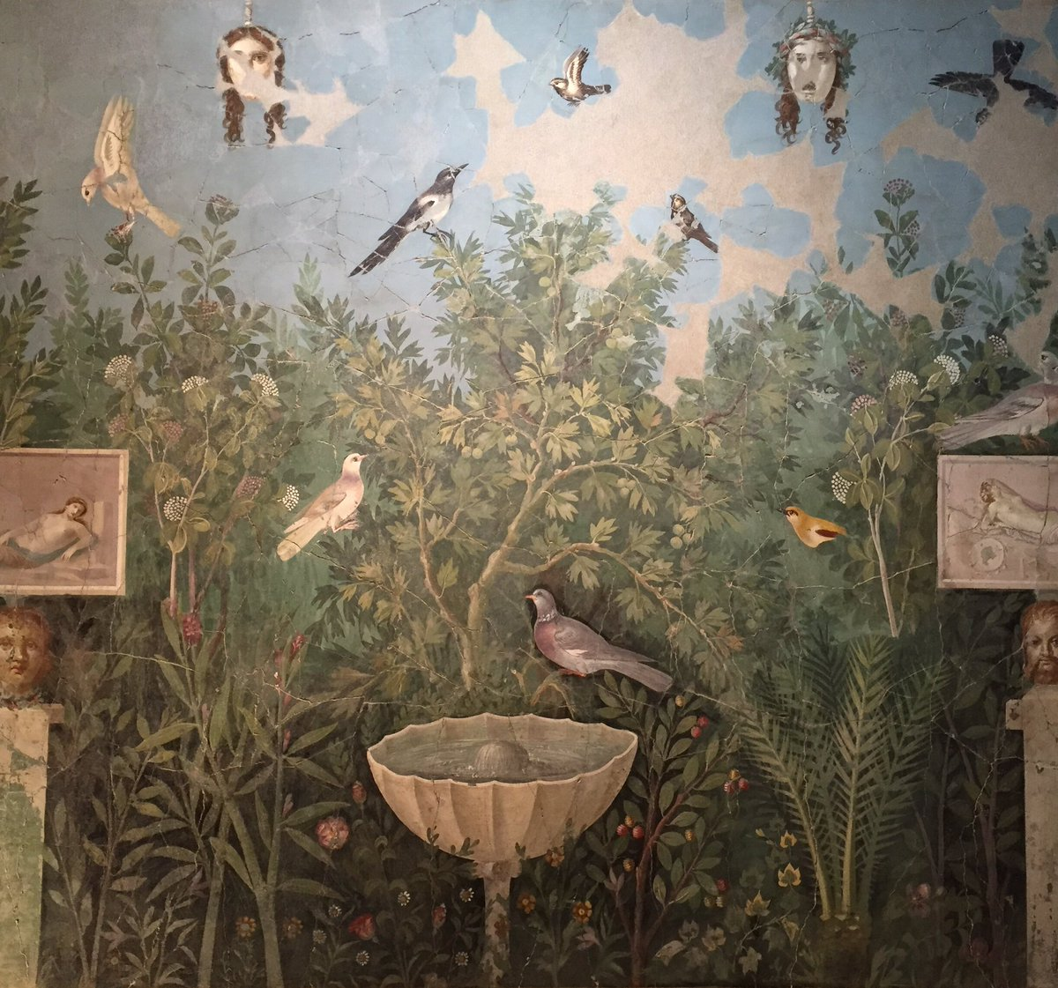

Fresco, Casa del Bracciale d’ora, Pompeii, summer triclinium, Pompeii 30-35 CE /

Jardins de Pompeii, fresque, Maison du bracelet d’or / Pompeianischer Garten

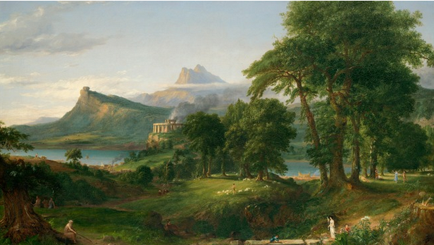

Thomas Cole, *The Course of Empire: The Pastoral or Arcadian State*, 1834,  
New-York Historical Society.

Question 2 :

What are the main characteristics of the description of the *locus terribilis* in the texts of the pensum?

You should base your answer on your knowledge of the texts and the works you have studied.

**LATIN MARKING SCALE**

**Part 1: Reading Skill: Unknown Texts – Total 30 points**

|  |  |  |  |  |  |  |  |  |  |  |
| --- | --- | --- | --- | --- | --- | --- | --- | --- | --- | --- |
| **ASSESMENT CRITERIA** | | | | | | | | | | |
| **a) Non-literary text** | **6 points** | | | | | | | | | |
| Understanding the overall meaning | **6** | | **5** | | **4** | | **3** | | **2-0** | |
| Excellent understanding of the quote | | Very good understanding of the quote | | Good understanding of the quote | | The quote is partially understood | | The quote is insufficiently understood, even with mistakes | |
| **b) Literary text** | **24 points** | | | | | | | | | |
| Understanding the meaning of the text | **10** | **9** | | **8** | **7-6** | **5** | | **4-3** | | **2-0** |
| Excellent understanding of the text | Very good understanding of the text | | Good understanding of the text | Satisfactory understanding of the text | Sufficient understanding of the text | | The text is partially understood | | The quote is insufficiently understood, even with mistakes |
| Identification of the syntactical structures of the text | **10** | **9** | | **8** | **7-6** | **5** | | **4-3** | | **2-0** |
| Syntactical structures excellently rendered | Syntactical structures very well rendered | | Syntactical structures well rendered | Syntactical structures satisfactorily rendered | Syntactical structures irregularly rendered | | Syntactical structures partially rendered | | Syntactical structures insufficiently rendered, even with mistakes |
| Quality of expression | **4** | | **3** | | **2** | | **1** | | **0** | |
| Excellent lexical and syntactical richness Very clear and very correct expression conveying the text register very well | | Very good lexical and syntactical richness Clear and correct expression conveying the text register very well | | Satisfactory lexical and syntactical richness Satisfactory expression conveying partially the text register very well | | Limited lexical and syntactical resources Expression lacking fluidity and fairly not conveying the text register | | Poor lexical and syntactical resources Expression very insufficient, with many mistakes | |

**LATIN MARKING SCALE**

**Part 2: Reading Skill: Known Texts – Total 40 points**

|  |  |  |  |  |  |  |  |  |  |  |  |
| --- | --- | --- | --- | --- | --- | --- | --- | --- | --- | --- | --- |
| **ASSESMENT CRITERIA** | | | | | | | | | | | |
| **1. Grammar** | **5 points** | | | | | | | | | | |
|  | **5** | | **4** | | **3** | | | **2** | | **1-0** | |
| Morphological and syntactical elements are excellently analysed and recognised | | Morphological and syntactical elements are very well analysed and recognised | | Morphological and syntactical elements are well analysed and recognised | | | Morphological and syntactical elements are partially analysed and recognised | | Morphological and syntactical elements are insufficiently analysed and recognised, even with mistakes | |
| **2. Etymology** | **5 points** | | | | | | | | | | |
|  | **5** | | **4** | | **3** | | | **2** | | **1-0** | |
| Lexical elements are excellently analysed | | Lexical elements are very well analysed | | Lexical elements are well analysed | | | Lexical elements are partially analysed | | Lexical elements are insufficiently analysed | |
| **3. Analysis of one part of the text** | **20 points** | | | | | | | | | | |
|  | **20-19** | **18-17** | | **16-15** | | **14-12** | **11-9** | | **8-5** | | **4-0** |
| Excellent awareness of literary and stylistic implications to analyse the text | Very fine awareness of literary and stylistic implications to analyse the text | | Good awareness of literary and stylistic implications to analyse the text | | Satisfactory awareness of literary and stylistic implications to analyse the text | Sufficient awareness of literary and stylistic implications to analyse the text | | Partial awareness of literary and stylistic implications to analyse the text | | Very little awareness of literary and stylistic implications to analyse the text t |
| **4. Comparison of translations** | **10 points** | | | | | | | | | | |
|  | **10** | **9** | | **8** | | **7-6** | **5** | | **4-3** | | **2-0** |
| Excellent comparison of translations Very accurate judgement | Very good comparison of translations Accurate judgement | | Excellent comparison of translations Adequate judgement | | Satisfactory comparison of translations Satisfactory judgement | Sufficient comparison of translations Sufficient judgement | | Partial comparison of translations Partial judgement | | NO comparison and judgement |

**LATIN MARKING SCALE**

**Part 3: Written response – Total 30 points**

|  |  |  |  |  |  |  |  |  |  |  |  |  |  |  |
| --- | --- | --- | --- | --- | --- | --- | --- | --- | --- | --- | --- | --- | --- | --- |
| **ASSESMENT CRITERIA** | | | | | | | | | | | | | | |
| **1. Follow instructions to write a text** | **3 points** | | | | | | | | | | | | | |
|  | **3** | | | **2** | | | | **1** | | | | **0** | | |
| Instructions perfectly followed | | | Instructions well followed | | | | Instructions partially followed | | | | Instructions not followed | | |
| **2. Making use of knowledge of the programme (content, themes, works)** | **15 points** | | | | | | | | | | | | | |
|  | **15-14** | **13-12** | | | **11-9** | | **8-7** | | **6-5** | | **4-3** | | | **2-0** |
| Excellent knowledge of the programme | Very good knowledge of the programme | | | Good knowledge of the programme | | Satisfactory knowledge of the programme | | Sufficient knowledge of the programme | | Partial knowledge of the programme | | | Very poor knowledge of the programme |
| **3. Express a personal point of view with relevant arguments** | **7,5 points** | | | | | | | | | | | | | |
|  | **7,5-7** | | **5-6** | | | **4** | | | | **3-2** | | | **1-0** | |
| The personal point of view is excellently expressed with very relevant arguments | | The personal point of view is very well expressed with relevant arguments | | | The personal point of view is satisfactorily expressed with appropriate arguments | | | | The personal point of view is partially expressed with poor arguments | | | No point of view, no arguments | |
| **4. Suitable use of language** | **4,5 points** | | | | | | | | | | | | | |
|  | **4,5-4** | | | **3** | | | | **2** | | | | **1-0** | | |
| Excellent use of language | | | Satisfactorily suitable use of language | | | | Sufficiently proper use of language | | | | Insufficiently proper use of language | | |

1. . *superi, -orum*, m: the gods (on high).
2. . *egero, egerere, egessi, egestum*: carry out, discharge.
3. . *modo*: just now, at that moment.
4. . *caesaries,ei,f*: long, flowing hair.
5. . *deus*: the god, here Apollo.
6. . *lugebere*: *lugeberis*.