**Preparation of the subjects for the BAC written exam: Generic matrix for History 4P**

|  |  |  |  |  |  |  |
| --- | --- | --- | --- | --- | --- | --- |
| **Task**  **Test element.** | **Competence** | **Weighting expressed as a % (of the section)** | **Learning objective** | **Question(s)** | **Evaluation/**  **marking** | **Weighting expressed in marks** |
| **Part 1 :** *Document analysis*  ***(Questions 1.1, 1.2. 1.3., 1.4.)*** | **1**  **Knowledge and understanding** | +/- 35 % | Select relevant historical knowledge in one or more documents.  Understand a historical fact in context  Show understanding of historic processes: causes and consequences, change and continuity  Deploy relevant, detailed and in-depth knowledge. | **1.1, 1.2. and 1.4.**  **1.1**  **1.4**  **1.4** | See the descriptors of levels achieved and the marking grid specific to the exam. | 17 |
|  | **2**  **Application and interpretation** | +/- 25 % | Identify points of similarity and difference.  Identify points of view and interpretation  Deploy historic knowledge as a source of evidence. | **1.2.**  **1.2.**  **1.3. and 1.4.** | 12 |
|  | **3**  **Synthesis and evaluation** | +/- 40 % | Know how to differentiate sources: primary and secondary sources, the type of source, text, image, statistics, etc.  Recognise the subjective nature of historic sources  Assess the value and limits of documents as sources of evidence about the past  Synthesise evidence from both historical sources and background knowledge | **1.2. and 1.3.**  **1.3.**  **1.3.**  **1.4.** | 21 |
| **Part 1** |  |  |  |  |  | **50** |
| **Part 2:** *Structured responses*  ***(Questions 2.1, 2.2., 2.3)*** | **1**  **Knowledge and understanding** | +/- 25% | Deploy accurate, relevant and detailed in-depth knowledge of the past. | **2.1., 2.2., 2.3.** | See the descriptors of levels achieved and the marking grid specific to the exam. | 12 |
|  | **2**  **Application (of knowledge) and interpretation** | +/- 20% | Select and classify arguments  Show awareness that events in the past have multiple explanations.  Use different approaches to and interpretations of questions and historic events. | **2.2., 2.3.**  **2.2., 2.3.**  **2.2., 2.3.** | 10 |
|  | **3**  **Synthesis and evaluation** | +/- 15% | Evaluate the different approaches to and interpretations of historical issues and events. | **2.3.** | 8 |
|  | **4**  **History communication skills** | +/- 40% | Formulate questions and respond to them: make hypotheses and evaluate them  Base writing on ideas, analysis and pertinent arguments  Write balanced, coherent and focused historical explanations taking into account multiple factors  Produce analytical and evaluative answers about historical issues and events in depth  Suggest conclusions | **2.3.**  **2.2. and 2.3.**  **2.2. and 2.3.**  **2.3.**  **2.3.** | 20 |
| **Part 2** |  |  |  |  |  | **50** |
| **Total** |  |  |  |  |  | **100** |

**Paper – specific matrix for History PART 1 and 2**

|  |  |  |  |  |  |  |
| --- | --- | --- | --- | --- | --- | --- |
| EXCELLENT | VERY GOOD | GOOD | SATISFACTORY | SUFFICIENT | INSUFFICIENT | FAIL |
| 100-90 | 89-80 | 79-70 | 69-60 | 59-50 | 49-21 | 20-0 |

**Reminder: for the European Baccalaureate if is considered that if a student has obtained 50 marks out of 100 he/she is considered to have reached a sufficient level.**

|  |  |  |  |  |  |  |  |  |
| --- | --- | --- | --- | --- | --- | --- | --- | --- |
| **Competence (and weighting expressed in % for part 1.** | **Learning objective** | **Questions of Part 1** | | | | | | **Weighting expressed in marks.** |
| **6 marks** | **1.2**  **12 marks** | | **1.3**  **12 marks** | | **1.4.**  **20 marks** |
| **1**  **Knowledge and understanding**  **(**+/- 35 %) | Select relevant historical information in one or more documents. | 0 – 100%  90 | 0-100%  80 | | X | | 0-100%  80 | 17 |
| Understanding a historical fact in context | 0-100%  100 | X | | X | | X |
| Demonstrate an understanding of historical processes: cause and effect; continuity and change, etc. | X | X | | X | | 0-100%  50 |
| Deploy accurate, relevant and detailed in-depth knowledge | X | X | | X | | 0-100%  50 |
| **2**  **Application (of knowledge) and interpretation**  **(**+/- 25 %) | Identify similarities and differences | X | 0-100%  100 | | X | | X | 12 |
| Identify points of view and interpretations | X | 0-100%  100 | | X | | X |
| Deploying historical knowledge as evidence | X | X | | 0-100%  100 | | 0-100%  100 |
| **3**  **Synthesis and evaluation**  **(**+/- 40 %) | Know how to differentiate between primary and secondary sources; the type of source: text,pictorial, statistics, etc. (C3) | X | 0-100%  60 | | 0-100%  80 | | X | 21 |
| Recognise the subjective nature of historic sources | X | X | | 0-100%  80 | | X |
| Assess the value and limits of documents as sources of evidence about the past | X | X | | 0-100%  100 | | X |
| Synthesise evidence from both historical sources and background knowledge | X | X | | X | | 0-100%  60 |
| **Total Part 1** |  |  |  | |  | |  | **50** |
| **Competence (and weighting expressed in % for part 2)** | **Learning objective** | **Questions of Part 2** | | | | | | **Weighting expressed in marks.** |
| **2.1.**  **6 points** | | **2.2.**  **16 points** | | **2.3**  **28 points** | |
| **1.**  **Knowledge and understanding**  **(**+/- 25%) | Deploy accurate, relevant and detailed in-depth knowledge of the past. | 0-100%  80 | | 0-100%  50 | | 0-100%  85 | | 12 |
| **2**  **Application (of knowledge) and interpretation**  **(**+/- 20%) | Select and classify arguments | X | | 0-100%  50 | | 0-100%  75 | | 10 |
| Show awareness that events in the past have multiple explanations. | X | | 0-100%  50 | | 0-100%  50 | |
| Use different approaches to and interpretations of questions and historic events. | X | | 0-100%  50 | | 0-100%  50 | |
| **3**  **Synthesis and evaluation**  **(**+/- 15%) | Evaluate the different approaches to and interpretations of historical issues and events. | X | | X | | 0-100%  50 | | 8 |
| **4**  **History communication skills**  **(**+/- 40%) | Formulate questions and respond to them: make hypotheses and evaluate them | X | | X | | 0-100%  80 | | 20 |
| Base writing on ideas, analysis and pertinent arguments | X | | 0-100%  50 | | 0-100%  60 | |
| Write balanced, coherent and focused historical explanations taking into account multiple factors | X | | 0-100%  50 | | 0-100%  60 | |
| Produce analytical and evaluative answers about historical issues and events in depth. | X | | X | | 0-100%  60 | |
| Suggest conclusions | X | | X | | 0-100%  60 | |
| **Total Part 2** |  |  | | | | | | **50** |
| **Total of the two parts** |  |  | | | | | | **100** |

*The learning objectives are evaluated each time as a percentage and are then weighted in points.* ***The figures in green serve as an example.***

|  |  |
| --- | --- |
| c | **Sample Bac written examination** |

|  |
| --- |
| **HSTORY**  **(4 HOUR OPTION COURSE)** |

**DATE:**

**LENGTH OF THE EXAMINATIONS: 3 Hours (180 minutes)**

**PERMITTED EQUIPMENT: NONE**

**SPECIAL REMARKS**: **ANSWER ALL QUESTIONS IN BOTH**

**PART 1 and PART 2**

**PART 1 and PART 2 carry equal marks**

**PART 1**

**RESEARCH OF DOCUMENTS**

**Part of syllabus:**

**Compulsory Core Europe 7– Europe in the making (1945 to today)**

**ANSWER all THE QUESTIONS**

**Source A**

***A cartoon from the British cartoonist David Low published in the Manchester Weekly Guardian, on 19 October 1956.***

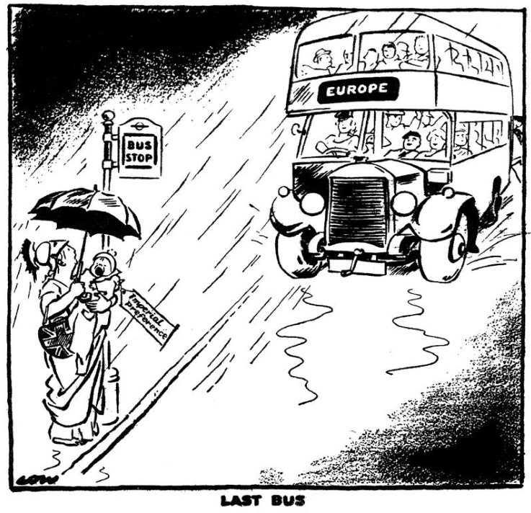

The label on the baby’s coat says “Imperial preference”.

“Last Bus”

From: [www.cvce.eu](http://www.cvce.eu)

**Source B**

***A poster from the French Communist party, published in 1952.***

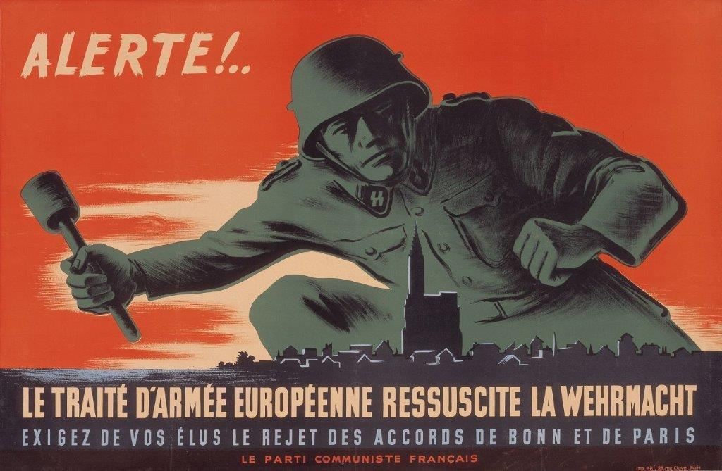

Text:

The Treaty of the European Army (European Defense Community) revives the German Army.

From: [www.cvce.eu](http://www.cvce.eu)

**Source C**

**An extract from an article entitled ‘A high price', published in the German Newspaper *Süddeutsche Zeitung*, on 1 March 1957, commenting on the Treaties of Rome.**

After so many European projects have come to a regrettable end in the past, the Coal and Steel Community being the only exception, tangible success has finally been achieved. This is welcome to everyone who thinks further than their own borders. The general open-mindedness has, however, given way to a visibly cool reception since details became known. And that is understandable.

If we look at it more closely, there is not much cause for boundless enthusiasm — the whole undertaking is attended by too many reservations, encumbrances[1] and also sacrifices. It will be possible, no doubt, to overlook the fact that, from the outset, only a Little European solution is on offer whereas an international division of labor becomes all the more appropriate, the larger the context in which it takes place. From this point of view alone, a free-trade zone involving the 17 OEEC[2] states would be preferable.

From: [www.cvce.eu](http://www.cvce.eu)

**Source D**

**An extract from an article entitled How the Italian “Communist Party sees the Common Market”, from the Italian Communist newspaper *L’Unità*, published on 24 March 1957, commenting on the Treaties of Rome**.

To begin with, we must condemn the fact that both Treaties are the expression and instrument of a policy that seeks to divide Europe ever more deeply into two opposing military blocs. The Treaties are in fact directly linked to the Atlantic Pact and the Western European Union[3]. They are based on the premise, and subject to the condition, of West German rearmament, and furthermore their goal is to allow West Germany the possible military use of atomic energy. They do not promote a process of détente, nor are they directed towards peaceful co-existence among countries with different social systems; they do not contribute to European security and peace. Rather, they tend to reinforce not only the political division of Europe but also the divide between European and world markets.

From: [www.cvce.eu](http://www.cvce.eu)

**Source E**

**An extract from the Memoirs of the West German Chancellor Konrad Adenauer, 1955-1959, published in 1967.**

In the year 1957 a great step forward was achieved in the process of European unity. On the 25th March 1957 the Rome Treaties, concerning the European Economic Community and EURATOM were signed. We could not have found a more significant place for the signing than the esteemed city of Rome. When we look back today to identify the foundations of Europe’s future, the greatest legacy to which Rome bears witness was our commitment. The signing of the treaty was an event of the greatest economic and political significance. As a result of the worldwide developments following the war, no economy of a single European state could remain healthy in the long term, because the economic territory of the each European state was too small.

From: Konrad Adenauer, *Memoirs*, *1955-1959*, Volume 3, Stuttgart 1967.

**PART 1**

**Research of documents**

**Using the sources and your own knowledge answer all the following questions:**

1. Explain the message of the cartoon in Source A.

**6 Marks**

1. Compare and contrast Sources C and D regarding the Treaties of Rome.

**12 Marks**

(Identify both similarities and differences between the sources).

1. Assess the value and limitations of Source A, B and E in studying the construction of Europe in the 1950’s. **12 Marks**
2. Using the sources and your own knowledge, evaluate the process of European integration between 1945 and 1973.

**20 Marks**

**TOTAL: 50 Marks**

**PART 2**

**Structured Response – Compulsory Themes**

**Answer all the following questions:**

1. What have Maoism and Stalinism in common? Give two examples.

**6 Marks**

1. With reference to at least one specific example you have studied, explain

the role of external factors in the decolonisation process after 1945.

**16 Marks**

1. To what extent were Mao’s policies and campaigns successful in establishing political control over the Chinese people in the years 1949 to 1966?

**28 Marks**

**TOTAL: 50 Marks**



**History Bac Paper**

**Marking scheme – General structure**

**Example**

|  |
| --- |
| **PART 1** |
| **1. The first question will test understanding of a source or part of a source.**  *If more than two marks are awarded for any part of question 1, the marking guidelines must recognise different levels of response.*  **(6 marks)**  **L1 = 0-2 marks**  A limited description of the cartoon  **L2 = 3-4 marks**  A good description of the main elements of the cartoon without context  **L3 = 5-6 marks**  A good description supported with contextual information   1. **Explain the message of the cartoon (Source A).**     **(6 marks)**  **Indicative content:**   * The European bus is arriving, Brittania is deciding whether or not get on * Label “Imperial preference” – Britain is holding on to her colonies/commonwealth * “Last Bus” – one last chance for Britain to join the European project * “Rain” – it is better to be on the bus than to stand outside * Contextual information – eg. Britain has already shown herself unwilling to participate in European integration eg. by deciding not to join the ECSC   **Other relevant points can be accepted** |
| 1. **The second question will test analysis of sources through the comparison and contrast of two or three sources.**   **(12 marks)**  *If sources are discussed separately ‘end-on-end’ without explicit linkage award 6 marks maximum.*  *1 similarity or 1 difference, max 8 marks*  *Only similarities or differences max 10 marks*  *For each additional relevant similarity or difference award two marks up to 10 marks*  *For maximum 12 marks expect at least two differences and one similarity (or vice versa) and a detailed running analysis of comparison and contrast*  **_________________________________________________________________**   1. **Compare and contrast Sources C and D regarding the Treaties of Rome.**   (Identify **both similarities** and **difference** between the sources).  **(12 marks)**  **Indicative content:**  **Similarities:**   * Both sources are from newspapers and both are 1957 * Both sources come from states about to join the EEC * Both sources point out negative aspects of the Treaties of Rome * Both sources accept that not everyone thinks the treaties are to be welcomed and that there are problems and difficulties arising from the treaties   **Differences**:   * Source C is German, source D is Italian * Source C talks about unity, source D talks about division * Source C is focussed on economy, source D is dealing with security * Source C is generally dealing with Europe while source D is concerned especially with Germany * Source C regards the treaties as partially successful, while source D doesn’t * Source C thinks a bigger 17 members community would be better, source D doesn’t want the treaties |
| 1. **3. The third question will test analysis of the utility of two or three sources with** 2. **reference to their provenance, author and content**   **(12 marks)**  *Only one source considered: maximum 4 marks*  *Only two sources: maximum 8 marks*  *Only strengths or weaknesses considered: maximum 9 marks*  *For a maximum of 12 marks candidates must refer to both value and limitation of all the three sources in their assessment. One well-made point about both value and limitation can be enough for each source but also allow multiple points to compensate.*   1. **Assess the value and limitations of Source A, B and E in studying the construction of Europe in the 1950´s.**   **(12 marks)**  **Indicative content:**  Source A  **Document values**   * The document gives us an idea of the British position on European integration, their pre-occupation with imperial matters and the choices they are facing, etc.   **Document limitations**   * It is a cartoon, there is no context or explanation * A cartoon is always limited in perspective, in this case it is just one person’s view * The cartoon is misleading because it looks like that Brittania wants to get on the bus, in reality she didn’t   Source B  **Document values**   * Gives us the view of the French communists who are suspicious of and opposed to European Integration * We can see how there is still a fear of a re-emerging German army not long after World War Two with the proposal to create the E.D.C. * The source shows communists in France are willing to use the democratic process * The source shows that communists want to influence public opinion to reject the E.D.C.   **Document limitations**   * It is not objective, it is subjective * Nothing is known about how this poster was distributed and received in France   Source E  **Document values**   * Document E is a primary source from the German Chancellor, giving us his positive views about European Integration * The source gives us a factual information about the Treaties of Rome and Euratom * The source shows how Europe politicians were committed to the idea of, and the importance of strengthening the European economy   **Document limitations**   * Adenauer only gives economic reasons for joining the E.E.C. whereas in   reality there were other reasons such as making Germany respectable and  acceptable again |
| 1. **The fourth question will test synthesis of sources and contextual knowledge based on one of the ten sub-questions from year 7 European Core Units (Europe 4, 5, 6, 7).**   **(20 marks)**  *If only sources or own knowledge is used: maximum 14 marks*  *For maximum 20 marks expect argument, synthesis of source material and own knowledge, as well as explicit references to the sources used and a direct answer to the question set.*   |  |  | | --- | --- | |  | 1. **Using the sources and your own knowledge, evaluate and explain the process of European integration between 1945 and 1973.** |   **(20 marks)**  **Indicative content:**  **From the sources:**   * Source A – Britain and if she will join the European Project or not * Source B – Highlights communist opposition to the idea of common defence in Europe * Source C – Shows how the road to European integration faced difficulties and challenges and some defeats and successes * Source D – shows how, in the context of Cold War, it was difficult to integrate Europe and that the motives behind the project were questioned by some * Source E – Shows how the treaties were so important for the future of Europe   **From own knowledge**:   * European integration against the background of the Cold War * Re-constructing Europe after World War Two * Future enlargement and /or deeper integration * Opposition to the project from different sources at different times, for example communists, de Gaulle in the 1960’s, etc. * Three new member States in 1973: U.K., Ireland and Denmark |
| **PART 2** |
| 1. **The first question will test selective factual recall through description and/or by definition. If more than two marks are awarded for any part of question 1, the marking guidelines must recognise different levels of response.**     **(6 marks)**  **L1 = 0-2 marks**  This answer is characterized by vague basic knowledge, little precise factual support, significant brevity and possible factual inaccuracy.  **L2 = 3-4 marks**  This answer is characterized by good knowledge, some precise factual support (names, places, dates etc.) and accuracy.  **L3 = 5-6 marks**  This answer is characterized by excellent knowledge, multiple examples of precise factual support and accuracy. An award of 6 marks does not mean that the answer is flawless but that little extra might be expected given the constraints of time.  **___________________________________________________________________**  **1. What have Maoism and Stalinism in common? Give two examples.**  **(6 marks)**  **Indicative content:**   * Cult of personality. * Marxist ideology. * Dictatorship, not democracy. * Planned economies, using 5-year plan5. * Elimination of political opposition. * The pre-eminence of the State over the individual. * One Party System. |
| **2. The second question will test factual recall and explanation.**  **(16 marks)**  ***L1 = 0-5 marks***  *This answer is characterized by vague basic knowledge, no factual support, significant brevity, incoherence and factual inaccuracy.*  ***L2 = 6-9 marks***  *This answer provides a single explanatory factor that is explained or multiple factors that are not explained. This answer is characterized by some understanding, but little or no factual support (names, places, dates etc.); the answer is likely to lack coherence and accuracy.*  ***L3 = 10-13 marks***  *This answer provides multiple explanatory factors each of which is explained. This answer is characterized by good understanding, and some precise factual support (names, places, dates etc.); the better answer in this range is likely to be coherent and historically accurate.*  ***L4 = 14-16 marks***  *This answer provides a wider range of multiple explanatory factors, each of which is thoroughly explained. This answer is characterized by very good or excellent understanding and a wide range of precise factual support (names, places, dates etc.) In addition, this answer might provide coherence through broader and/or thematic factors. An award of 16 marks does not mean that the answer is flawless but that little extra might be expected given the constraints of time.*  **_______________________________________________________________**   1. **With reference to at least one specific example you have studied, explain the role of external factors in the decolonisation process after 1945.**   **(16 marks)**  **Indicative content:**   * World War Two was fought in the name of independence (eg: the Atlantic Charter 1941). There were many soldiers from the colonies fighting for this idea * The old imperial countries like France and Britain were weaker after the war especially economically and couldn’t afford to maintain all their colonies * The rise of left wing ideology in Western Europe after World War Two led to anti-imperialist governments eg: Atlee’s Labour Party in Britain * The role of the super powers in the Cold War. Both were ideologically opposed to imperialism * The role of the United Nations * The Bandung Conference (1955) and the role of non aligned countries * Ripple effect – eg: independence for Vietnam (1954) inspired independence movements in other countries eg: Algeria   **Other relevant points are acceptable** |
| 1. **The third question will test factual recall, explanation and evaluation.**     **(28 marks)**  *Note: If a student only provides one case study, maximum 19 marks. Two or more case studies, up to 28 marks using the grid for guidance.*  **___________________________________________________________________**  **3. To what extent were Mao´s policies and campaigns successful in establishing political control over the Chinese people in the years 1949 et 1966.**    **(28 marks)**  See generic Evaluative Written Response for more details. |

**Part 2 Question 3 - Evaluative Written Response Assessment Grid**

|  |  |  |  |
| --- | --- | --- | --- |
| **MARKS** | **connaissances et compréhension** | **Concepts** | **capacités** |
| 28 | Outstanding performance. It fully meets the requirements of the question. This does not mean that the performance is flawless but it implies that no fault can be found with the work other than very minor errors. The work displays evidence of independent thinking allied with excellent historical knowledge and analytical skills. | | |
| 26-27 | Wide range of knowledge. Accurate, relevant, organised. Deep understanding of historical context. | Evaluation of different motivations and interpretations. Very good grasp of the concepts relevant to the question. A wide perspective. | Coherent, logical, critical arguments. Perceptive historical evaluations. |
| 23-25 | Accurate, relevant and largely organised. Most issues addressed. Good understanding of historical context. | Good understanding of the concepts relevant to the question. | Well developed, structured and logical arguments. Sound historical judgements. |
| 20-22 | Mostly accurate and relevant:  Either:- a good body of evidence with only partial analysis,  Or: - a coherent argument with incomplete evidence. | Reasonable understanding of the relevant concepts. A historical perspective. | Some structure and analysis addressed to the question.  Either:- a coherent argument with only partial evidence,  Or: - partial analysis with a wide range of evidence. |
| 18-19 | Enough accurate and relevant knowledge, with some errors and/or omissions. | Familiarity with basic ideas. Some historical perspective. | Question addressed only partially or implicitly. More descriptive than analytical or may present argument based on insufficient evidence. |
| 16  -17 | Basic facts displayed but too many errors and irrelevant material. | Awareness of basic ideas but misunderstandings. | Simple narrative or description without conclusion. Little attention is paid to the question. |
| 11-14 | Some knowledge but major errors/omissions. | Confusion over basic concepts and ideas. | Refers vaguely to the general topic but little organisation and argument |
| 1-10 | A jumble of facts, error-filled, incoherent. | Confused and narrow. | Isolated facts or generalisations. Barely approaches the question or topic. |
| 0 | Answer not attempted. | Answer not attempted. | Answer not attempted. |

Use the **Knowledge and Understanding** column as the first point of reference and the other columns as a further guide for the mark.

1. Encumbrances – obstacles, constrains
2. OEEC – Organisation for European Co-operation (OEEC), June 1955. 61 p. p. 7; 25-51.
3. Atlantic Pact – NATO, Western European Union - a defense agreement and military alliance between several Western European countries.