Generic Matrix

|  |  |  |  |  |
| --- | --- | --- | --- | --- |
| **Element of examination** | **Competence** | **Weight in %** | **Weight in points** | **Learning Objectives** |
| Question 1  15 %  15 marks  Focus: Knowledge and understanding | **Knowledge and understanding** | ±40 | 15 | See syllabus |
| **Analysis (the application of ideas)** | ±40 |
| **Evaluation** | ±0 |
| **Skills and techniques (Selection, use and application)** | ±20 |
| Question 2  25%  25 marks  Focus: Skills and techniques | **Knowledge and understanding** | ±20 | 25 | See syllabus |
| **Analysis (the application of ideas)** | ±20 |
| **Evaluation** | ±20 |
| **Skills and techniques (Selection, use and application)** | ±40 |
| Question 3  30 %  30 marks  Focus: Analysis and evaluation | **Knowledge and understanding** | ±20 | 30 | See syllabus |
| **Analysis (the application of ideas)** | ±30 |
| **Evaluation** | ±30 |
| **Skills and techniques (Selection, use and application)** | ±0 |
| **Coherence/structure** | ±20 |
| Question 4  30 %  30 marks  Focus: Essay | **Knowledge and understanding** | ±20 | 30 | See syllabus |
| **Analysis (the application of ideas)** | ±30 |
| **Evaluation** | ±30 |
| **Skills and techniques (Selection, use and application)** | ±5 |
| **Coherence/structure** | ±15 |
| Total exam |  | 100% | 100 |  |

The above matrix outlines the suggested weightings of marks for the corresponding competences. These weightings are suggested and as is clear from the table may vary from question to question. You are strongly encouraged to consider the relative weightings when creating questions to ensure that the question style and focus is still preserved. This means for example that the weighting of a type two question remains skills and that for a type 3 remains analysis.

Sample Paper Specific Matrix

|  |  |  |  |  |  |  |
| --- | --- | --- | --- | --- | --- | --- |
| **Element of examination** | **Competence** | **Weight in %** | **Weight in ~~marks~~**  **points** | **Questions in Sample Paper** | **Evaluation/Marking** | **Learning Objective/Syllabus reference** |
| Question 1  15 %  15 marks  Focus: Knowledge and understanding | **Knowledge and understanding** | 50% | 7.5 | Q1Ai, Q1Aii Q1C, Q1D | Paper-specific Marking Scheme | See Syllabus |
| **Analysis (the application of ideas)** | 23% | 3.5 | Q1D | Paper-specific Marking Scheme |
| **Evaluation** | 0% | 0 | - |  |
| **Skills and techniques (Selection, use and application)** | 27% | 4 | Q1B | Paper-specific Marking Scheme |
| Question 2  25%  25 marks  Focus: Skills and techniques | **Knowledge and understanding** | 44% | 11 | Q2Aii, Q2B | Paper-specific Marking Scheme | See Syllabus |
| **Analysis (the application of ideas)** | 0% | 0 | - |  |
| **Evaluation** | 28% | 7 | Q2C | Paper-specific Marking Scheme |
| **Skills and techniques (Selection, use and application)** | 28% | 7 | Q2Ai, Q2Aii, Q2B | Paper-specific Marking Scheme |
| Question 3  30 %  30 marks  Focus: Analysis and evaluation | **Knowledge and understanding** | 40% | 12 | Q3A, Q3B, Q3Ci, Q3Cii, Q3D | Paper-specific Marking Scheme | See Syllabus |
| **Analysis (the application of ideas)** | 40% | 12 | Q3B, Q3Cii, Q3D | Paper-specific Marking Scheme |
| **Evaluation** | 7% | 2 | Q3D | Paper-specific Marking Scheme |
| **Skills and techniques (Selection, use and application)** | 6% | 2 | Q3Ci | Paper-specific Marking Scheme |
| **Coherence/structure** | 7% | 2 | Q3D | Paper-specific Marking Scheme |
| Question 4  30 %  30 marks  Focus: Essay | **Knowledge and understanding** | 20% | 6 | Question as a whole | Paper-specific Marking Scheme | See Syllabus |
| **Analysis (the application of ideas)** | 30% | 9 | Question as a whole | Paper-specific Marking Scheme |
| **Evaluation** | 30 % | 9 | Question as a whole | Paper-specific Marking Scheme |
| **Skills and techniques (Selection, use and application)** | 7% | 2 | Question as a whole | Paper-specific Marking Scheme |
| **Coherence/structure** | 13% | 4 | Question as a whole | Paper-specific Marking Scheme |

The above matrix outlines the suggested weightings of marks for the corresponding competences which are related to the sample exam paper. You are strongly encouraged to consider the relative weightings when creating questions to ensure that the question style and focus is still preserved. This means for example that the weighting of a type two question remains skills and that for a type 3 question remains analysis

**Sample BAC Written Paper**



**LENGTH OF EXAMINATION: 3 HOURS (180 minutes)**

**ALL QUESTIONS MUST BE ANSWERED**

**QUESTION 1 : (15 MARKS)**

**QUESTION 2 : (25 MARKS)**

**QUESTION 3 : (30 MARKS)**

**QUESTION 4 : (30 MARKS)**

**EUROPEAN BACCALAUREATE SAMPLE PAPER GEOGRAPHY - 4 HOUR OPTION**

**Question 1: Population 15 marks**

a.

(i) **Define** birth rate. **(1 mark)**

(ii) **Define** dependency ratio. **(1 mark)**

**Figure 1.1: Population density 2017**

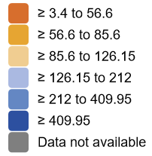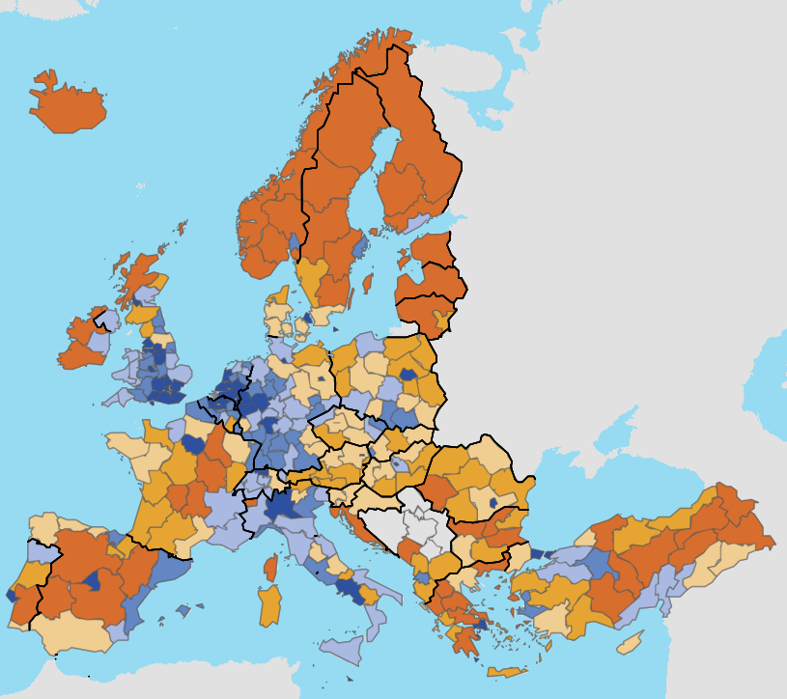

Source: <https://ec.europa.eu/eurostat/databrowser/view/tgs00024/default/map?lang=en>

b. **Describe** population density across the EU with reference to ***Figure 1.1.***  **(4 marks)**

c. Briefly **explain** one physical and one human factor affecting population density across the EU. **(4 marks)**

d. Briefly **outline** the differences between core and periphery characteristics, with reference to examples.

**(5 marks)**

**EUROPEAN BACCALAUREATE SAMPLE PAPER GEOGRAPHY - 4 HOUR OPTION**

**Question 2: Natural Environment of Europe 25 marks**

a.

(i) Using ***Figures 2.1 and 2.2*** **identify** and name **four** physical landforms.

**(2 marks)**

(ii) **Explain ONE** weathering process that shapes the physical geography of the Mt Blanc area shown.

**(4 marks)**

b. With the aid of a diagram **explain** the formation of TWO Glacial landforms. **(12 marks)**

c. **Evaluate** the ***advantages*** that the physical geography of the Alps have created for human activity.

**(7 marks)**

1

1

5

4

2

3

6

A

**Figure 2.1: Google Earth image of the approximate area shown on the map on Figure 2.2**

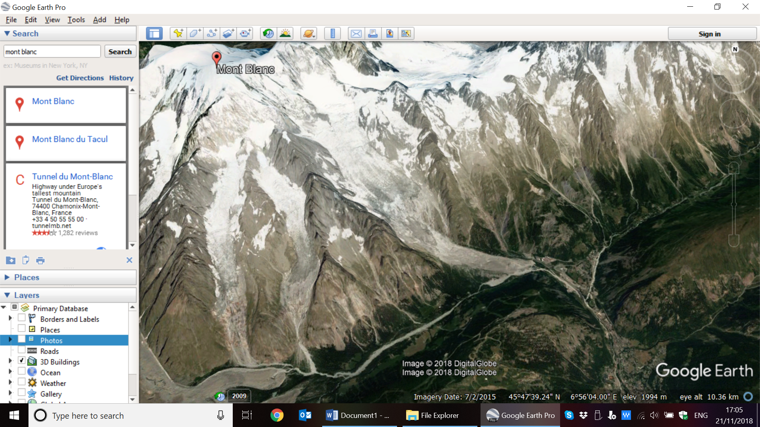

Source: Google Earth

**EUROPEAN BACCALAUREATE SAMPLE PAPER GEOGRAPHY - 4 HOUR OPTION**

**Figure 2.2: Map extract of part of the Mont Blanc area of the Alps**

**Scale 1:25 000**

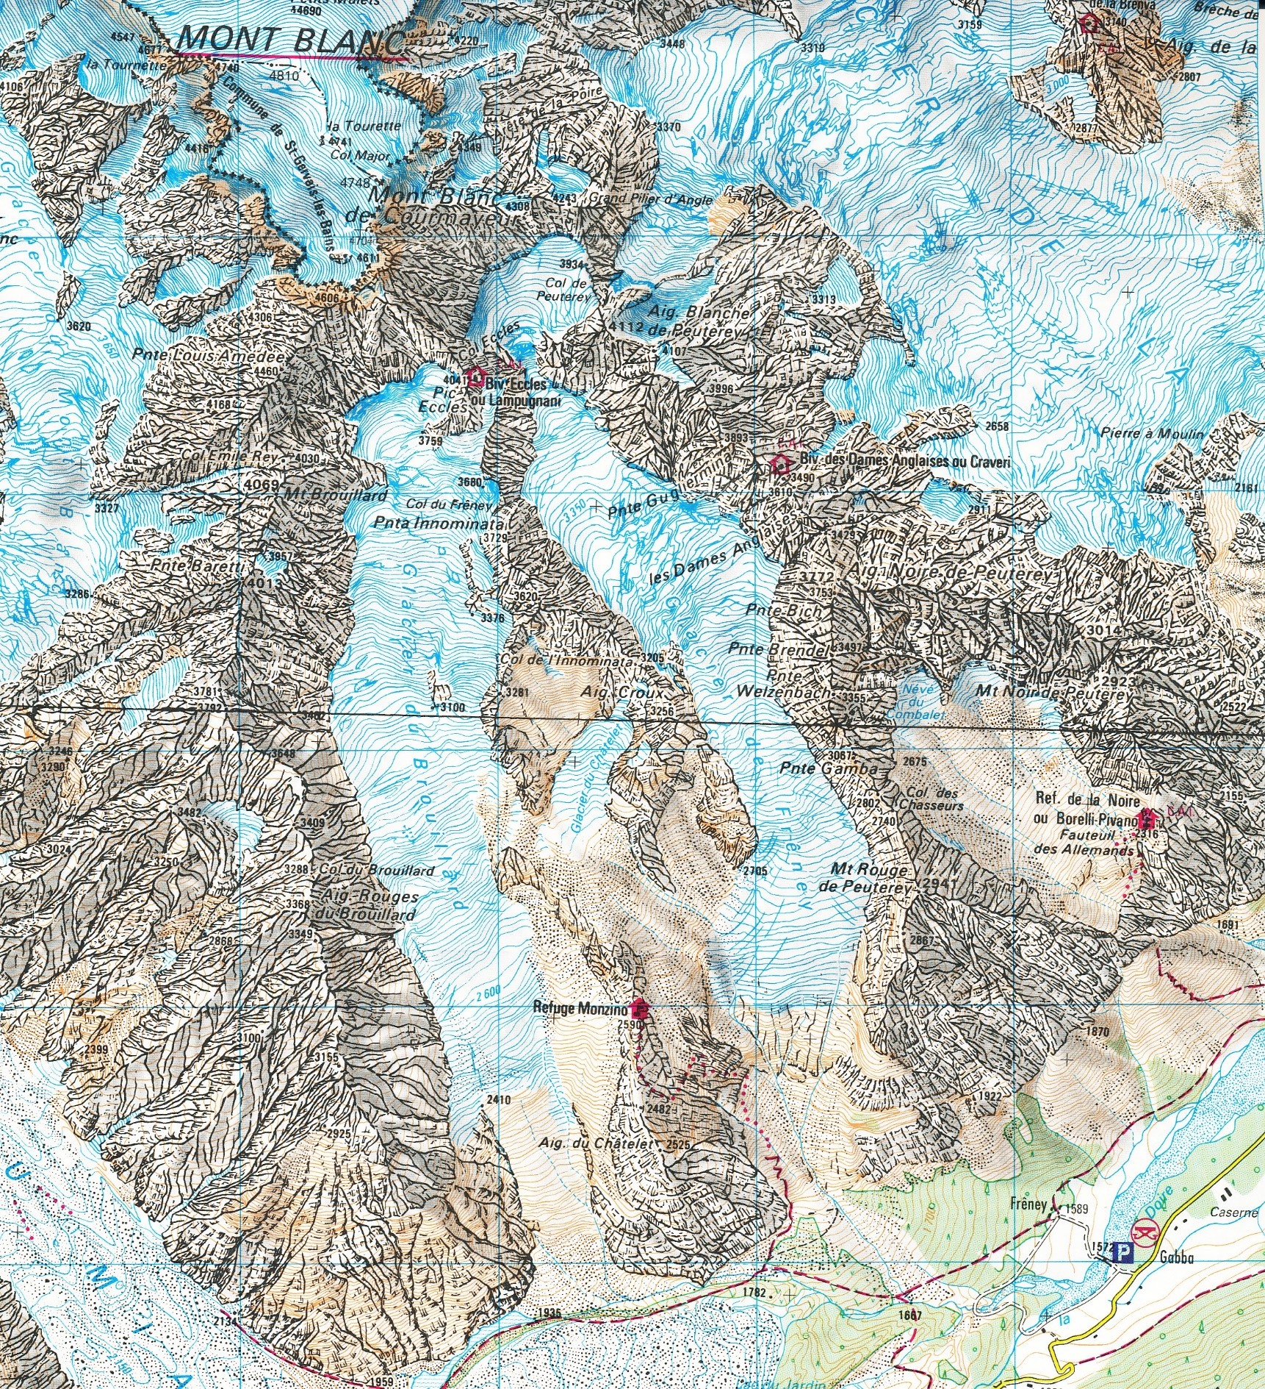

B

C

D

A

1

3

5

6

4

2

**Cliff**

Bare%20rock

**Scree/rocks**

Scree%20(loose%20rock)

**Contour**

**Interval**

**= 10 m**

6

A

3

1

4

5

1

2

4

3

1

2

1

A

5

6

Source: IGN

**EUROPEAN BACCALAUREATE SAMPLE PAPER GEOGRAPHY - 4 HOUR OPTION**

**Question 3: EU Issues and Challenges 25 marks**

a. **Define** environmental sustainability. (2)

b. With reference to ***Figure 3.1*** discuss the changing popularity of organic farming in comparison to intensive farming. **(8 marks)**

**Figure 3.1: Organic farming area in the EU 2010-2015**

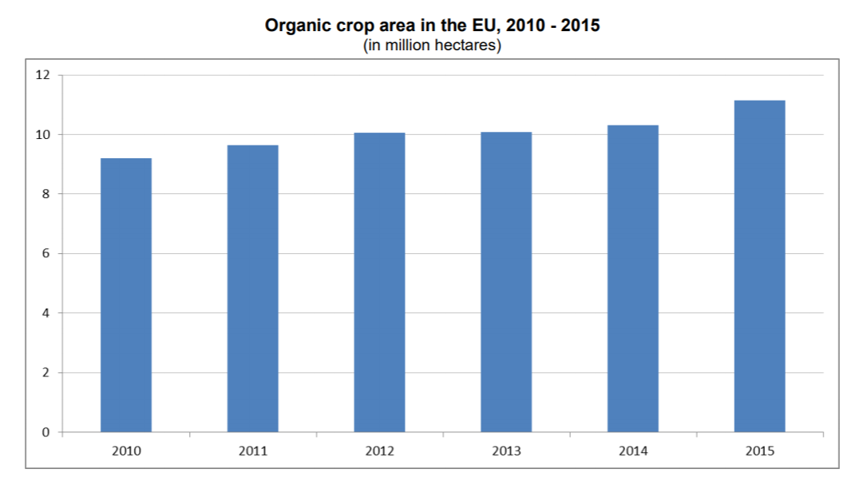

Source: <https://ec.europa.eu/eurostat/documents/2995521/7709498/5-25102016-BP-EN.pdf/cee89f9e-023b-4470-ba23-61a9893d34c8>

**Figure 3.2 An example of farm changes from 1960 to 2000**

|  |  |
| --- | --- |
|  |  |
| A UK farm before 1960 | A UK farm in 2000 |

c.

(i) With reference to ***Figure 3.2***, **identify** and **describe,** the typical changes that took place on farms, as a result of The Common Agricultural Policy, between 1960 to 2000.  **(6 marks)**

(ii) **Explain** how The Common Agricultural Policy has promoted food production.  **(4 marks)**

(d) **Evaluate,** with reference to ONE case study,the ways in which The Common Agricultural Policy may have helped protect the environment.  **(10 marks)**

**EUROPEAN BACCALAUREATE SAMPLE PAPER GEOGRAPHY - 4 HOUR OPTION**

**Question 4: Economy of the European Union 30 marks**

**Write an essay (minimum length 500 words, maximum length 1000 words) to evaluate the**

**following statement.**

***“The car industry in the European Union has been and always will be dynamic”.***

**Figure 4.1: Evolution of the Production of Car Manufacturing from 1960 to 2014 in selected European Union countries. (% of the total production)**

|  |  |  |  |
| --- | --- | --- | --- |
| **Year**  **Country** | **1960** | **2000** | **2014** |
| **Germany** | **35** | **30** | **38** |
| **Italy** | **12** | **9** | **2** |
| **Spain** | **1** | **16** | **13** |
| **Czech Republic** | **1** | **3** | **6** |
| **Poland** | **0** | **3** | **4** |

Source: <https://www.auto-forever.com/>

**In your essay, you should include the following:**

* Provide an introduction, with commentary on the essay title, *“The car industry in the European Union has been and always will be dynamic”.*
* Briefly describe and explain the data by making reference to ***Figure 4.1***.
* Explain the factors affecting the location of Car Industries in the European Union.
* Evaluate the implications of the changing location of the car industry in the European Union.
* Provide a conclusion.

**(30 marks)**

### Mark scheme (EN)

| Question | Sub | Part |  | Total | Mark details | Competences  Assessed | Learning Objective |
| --- | --- | --- | --- | --- | --- | --- | --- |
| 1 |  |  |  |  |  |  |  |
|  | a | i  ii | An appropriate **definition** | 2 | 2 x 1 mark | Knowledge and understanding | Describe & analyse the structure of population(Key terms in syllabus) |
|  | b |  | 4 x references to the map. Student has identified and accurately described different population densities i.e. high, low with accurate reference to the key. The student provides examples of specific cities/regions/countries. | 4 | 4 x 1 mark | Skills and techniques | Identify & explain the dynamic nature of population change |
|  | c |  | Two clear explanations i.e. ONE physical factor and ONE human factor affecting population density in the EU.  Explanations could include but not limited to.  HUMAN PHYSICAL  Administrative centre Climate  Transport Relief  Industry Soil  Education Water sources | 4 | 2 x 2marks | Knowledge and understanding | Identify & explain the dynamic nature of population change |
|  | d |  | Differences between Core and Peripheral characteristics  -Any TWO acceptable Physical or human differences i.e. economic/social/cultural differences, with example.  -Employment  -Transport  -Political representation  -Agriculture  -Services  Sample Answer:  -More developed transport infrastructure in core regions e.g. TAV/fast train connecting Milan to Turin however in less economically developed regions such as Southern Italy only 8% of ports are connected to railways in comparison to 48% in Northern Italy. = 2.5 marks | 5 | 2 x 2.5 marks | -Knowledge and Understanding  -Analysis (Application of ideas) | -Describe & explain the distribution and density of population, especially the importance of urban area,  -Identify & explain the dynamic nature of population change, |
| 2 |  |  |  |  |  |  |  |
|  | a | i | The student will correctly identify FOUR physical landforms that could be glacial or fluvial.  -The student also should use correct terminology to locate landforms on the map/photograph e.g. left centre background on the aerial photograph or an appropriate grid reference A2 on the Ordnance Survey Map to gain full marks  An Acceptable answer could be  Aretes can be identified in the left middle ground of the aerial photograph or A3 on the Ordnance Survey map. | 2marks | 4 x 0.5 mark | Skills and Techniques | Recognise the processes shaping the physical landscape |
|  | a | ii | Clear explanation  1 mark for correctly identifying ONE weathering process e.g. Freeze thaw action/Physical weathering.  3 marks for 2-3 well developed explanation points.  -Marks could be awarded for well labelled/annotated diagrams at the examiner/teacher’s discretion. | 4 marks | 1 x 4 marks | -Knowledge & understanding  -Skills & Techniques | Explain the processes that shape the landscape in the past and the present |
|  | b |  | -Any combination of landforms of Glacial erosion or deposition are acceptable.  -Landforms in a glacial or post-glacial environment are acceptable.  -For example: U-shaped valley, arete, corrie, lateral moraine, outwash plain, esker etc. (but not limited to).  --------------------  -0.5 mark for naming the landform, 0.5 mark for locating an example of the landform.  -5 marks diagrams/explanation of formation of landform which includes an explanation of the processes of erosion.  (This can be divided based on teacher discretion i.e  3 marks(explanation)+ 2 marks (diagram(s))  OR  2 marks(explanation)+ 3 marks (diagram(s))  OR  5 marks diagrams very well annotated/labelled. | 12 marks | 2 x 6 marks | -Knowledge & understanding  -Skills & Techniques | -Recognize the processes shaping  physical landscapes on OS maps |
| 2 | c |  | Level Marking | 7 marks |  | Evaluation | -Analyse and assess the suitability of a region (relief and climate) for human activity. |
|  |  |  | -If a student answers disadvantages only - max 3 marks can be awarded. |  |  |
|  |  |  | 0 Question remains unanswered or is completely incorrect. |  |  |
|  |  |  | 1-3 At lower end, the student may mention advantages but completes low level description or explanation and lacks any effort to evaluate. At upper end, additional mention of advantages may be included. |  |  |
|  |  |  | 4-5 At lower end, simple reference to evaluation is present. A conclusive statement is not reached/not effective. Limited evidence or critical thought. Vague/low level response at the lower end.  At the higher end evaluative statements are supported with some evidence however arguments are weakly explored. |  |  |
|  |  |  | 6-7 At lower end evidence of the ability to consider strengths/advantages of the Physical geography of the Alps for Human Activities is very good. Critical thought may show that strengths may come at a cost.  -Some key information may be missing.  -Students provide evidence/examples/case-study.  -A conclusive statement/view is included.  At the upper end there is excellent evidence of the ability to consider strengths/advantages of the Physical geography of the Alps for Human Activities. Critical thought will show that strengths may come at a cost.  -Students provide well supported evidence/examples/case-study.  -A conclusive statement/view is clearly included. |  |  |
| 3 | a |  |  |  |  |  |  |
|  |  |  | An appropriate definition of environmental sustainability. Reference should be made to the environment and not simply sustainability.  Concept may include the ability to use the environment and its resources today without undue negative and lasting environmental impacts for future generations. | 2 | 2 x 1 mark | Knowledge and understanding | - explain the concept of sustainability, |
|  | b |  |  |  |  |  |  |
|  |  | 0 | Question remains unanswered or is completely incorrect. |  |  |  |  |
|  |  | 1-3 | Basic analysis present however graph is very rarely referenced and without the use of specific values and data. The trend may be described but not explained. |  |  | Knowledge and understanding,  Analysis | - explain how agricultural policy promotes quality production and protects the environment, |
|  |  | 4-6 | Good analysis and description of the pattern or trend. Good knowledge and understanding of changes in organic farm production, however, explanations could be more detailed. |  |  |
|  |  | 7-8 | Clear interpretation of graph and references to data in describing pattern of increase. Developed answer with appropriate terminology that may link increase in production to CAP and environmental protection and increasing consumer demand. | 8 | Level marked |
|  | c |  |  |  |  |  |  |
|  |  | i | 0.5 marks for an appropriate identification of a change  1 mark for an appropriate corresponding description  Sample Answer:  In the figure it can be seen that farmers have changed grazing land in to a campsite. This is an example of how they have diversified their income.  Additionally, open land has been turned into a conservation area to protect land and encourage biodiversity as part of The Common Agricultural Policy (CAP).  Old farm buildings which may have been used for workers in the past are now being used as holiday homes. This brings in extra income for the farmer in summer.  A tea and cake shop has been built and this may use local produce from the farm. It extends the income stream for the farmer and may attract tourists to the area. = 6 marks | 6 | Simple marking  4 x 1.5 | Knowledge and understanding,  Skills | - explain how agricultural policy promotes quality production and protects the environment, |
|  |  | ii |  | 4 | Level marked | Knowledge and understanding,  Analysis |
|  |  | 0 | Question remains unanswered or is completely incorrect. |
|  |  | 1-2 | Satisfactory knowledge and understanding of CAP but with little or no direct reference to how it impacted agricultural output. Details or examples of specific measures are not mentioned. Answer lacks development. |  |
|  |  | 3-4 | Excellent knowledge and understanding of CAP and its impact on increased agricultural output. Especially in the early years of the policy (1962+). Reference may be made to the payment system and food waste. |  |
|  | d |  |  |  |  |  |  |
|  |  | 0 | Question remains unanswered or is completely incorrect. |  |  |  |  |
|  |  | 1-3 | Limited knowledge and understanding of the CAP and its environmental controls. Inaccuracies may be present or no example is given. Limited and often unsupported evaluative statements with no conclusive statement. Answer may often be vague and of a low level. | 10 | Level marked | Knowledge and understanding,  Analysis,  Evaluation,  Coherence and structure | -describe & explain the factors affecting intensive & extensive farming  - explain how agricultural policy promotes quality production and protects the environment, |
|  |  | 4-6 | Good knowledge and understanding of the CAP and its environmental controls. An example may be given but lacks details and key terminology. Reference to an example with location, date or facts is weak or lacks relevance. Evidence of the ability to consider strengths and weaknesses of CAP with relation to environmental protection present but arguments may lack balance or support. Answers are mostly coherent and organised. |
|  |  | 7-10 | Excellent knowledge and understanding of the CAP and its environmental controls. Detailed analysis and reference to an example with location, date or facts to support it. Clear evidence of the ability to consider the strengths and weaknesses of CAP’s environmental controls.  A conclusive statement is included and justified to reach full marks. Answers are very detailed and coherent. |

Question 4

|  |  |  |  |  |  |  |  |
| --- | --- | --- | --- | --- | --- | --- | --- |
| 4 |  | 0 | Question remains unanswered or is completely incorrect. | 30 |  | Knowledge and understanding  Analysis  Evaluation  Coherence and structure | -The car industry reflecting the spatial development of European industry.  -Evaluate the implications of the changing locations of these industries,  -Assess the implications of the changing requirements of these industries. |
|  |  | 1-30 | Refer to attainment descriptors. |

The nature of question four, the essay question, is to test student abilities in writing a coherent/structured essay.

The student must provide an effective response to the statement, based on discussion of relevant knowledge, to derive a conclusion which supports/rejects the given statement.

NB: Examiners have latitude in marking to reflect how students structure their essay e.g. students may adopt some variation from the suggested points and emphasise some points more than others. Although final mark involves a high degree of value judgement, examiners must refer to the criteria for good essay and the suggested mark scheme which are available to teachers (see Geography Syllabus, 4 period course Year 6/7. Reference 2016-12-D-21-en3- **updated version**).

The attainment descriptors should be used to reach a reasoned judgement about the quality of the essay and its ability to answer the question. A student scoring 100% for this essay would demonstrate most of the characteristics described in the excellent row of the attainment descriptors. A passing student, scoring 50% would demonstrate most of the characteristics described in the sufficient row of the attainment descriptors. Attention should be paid in particular to the coherence and structure column. Students choosing not to structure their response as an essay or not covering points in a structured fashion will accordingly be limited in their ability to reach the top marks.

A general guide for suggested essay structure:

* Introduce the theme with commentary on the essay title, *“The car industry in the European Union has been and always will be dynamic”.*
* Description: A description of the data by making reference to ***Figure 4.1***. 6
* Explanation: An analysis of the factors affecting the location of Car Industries in the EU
* Evaluate the implications of the changing location of the car industry in the European Union.
* Provide a conclusion: an overall evaluation of the statement

Total = 30 marks

|  |  |
| --- | --- |
| **Attainment descriptors** | **Marks allocated\*** |
| Knowledge and Understanding | 6 marks |
| Analysis | 9 marks |
| Evaluation | 9 marks |
| Skills & Techniques | 2 marks |
| Coherent Structure | 4 marks |
| Total Marks | 30 marks |

This marking allocation can be allocated at teacher discretion however Q4 will need to be considered as a whole.