Economics Generic Matrix
Element of examination | Questions | Competence | Weight in % | Learning Objectives | Evaluation/Marking | Weight in points
Question 1  (subdivided into 4 questions) |  | Knowledge | ±30 | 1. Apply economic concepts and theories  2. Understand the basic concepts of scarcity, choice and decision-making  3. Understand the major macroeconomic issues and the different approaches to their resolution  4. Identify structural changes in an economy and the forces behind them  5. Explain the impact of economic decisions on the environment  6. Exhibit an understanding of the world of work  7. Comprehend the ethical aspects of economic decisions | Paper-specific Marking Scheme | 33
 |  | Comprehension | ±20
 |  | Application | ±25
 |  | Analysis / Discussion | ±25
Question 2  (subdivided into 4 questions) |  | Knowledge | ±30 |  | Paper-specific Marking Scheme | 33
 |  | Comprehension | ±20
 |  | Application | ±25
 |  | Analysis / Discussion | ±25
Question 3  (subdivided into 4 questions) |  | Knowledge | ±30 |  | Paper-specific Marking Scheme | 34
 |  | Comprehension | ±20
 |  | Application | ±25
 |  | Analysis / Discussion | ±25
Total exam |  |  | 100% |  |  | 100

N.B.: A question encompasses the four competences. Each of its 4 subquestions may encompass more than one competence.
Overall:
Knowledge: +/- 30%
Comprehension: +/‐ 20%
Application: +/‐ 25 %
Analysis (and Discussion): +/25%

The above matrix outlines the suggested weighting of points for the corresponding competences. These weightings are suggested and as it is clear from the table may vary from question to question. You are strongly encouraged to consider the relative weightings when creating questions to ensure that the question style and focus are still preserved.

Sample Paper Specific Matrix
Element of examination | Competence | Weight in % | Questions in sample Paper | Learning Objectives | Evaluation/Marking | Weight in points
Question 1  (subdivided into 4 questions) | Knowledge | 34 | Q1a), Q1b), Q1d) | See syllabus | Paper-specific Marking Scheme | 11
 | Comprehension | 21 | Q1a),Q1c) |  |  | 7
 | Application | 24 | Q1a),Q1c) |  |  | 8
 | Analysis / Discussion | 21 | Q1d) |  |  | 7
Question 2  (subdivided into 4 questions) | Knowledge | 34 | Q2b), Q2d) | See syllabus | Paper-specific Marking Scheme | 11
 | Comprehension | 24 | Q2a), Q2c) |  |  | 8
 | Application | 24 | Q2a), Q2c) |  |  | 8
 | Analysis / Discussion | 18 | Q2d) |  |  | 6
Question 3  (subdivided into 4 questions) | Knowledge | 22 | Q3b), Q3c), Q3d) | See syllabus | Paper-specific Marking Scheme | 7
 | Comprehension | 26 | Q3a), Q3b) |  |  | 9
 | Application | 26 | Q3b), Q3c) |  |  | 9
 | Analysis / Discussion | 26 | Q3d) |  |  | 9
Total exam |  |  |  |  |  | 100

ECONOMICS
SAMPLE PAPER

Question 1
 |  | Page 1/2 | Points
Euro area selected indicators: Annual figures 2008-2017, 2018 & 2019 forecasts.
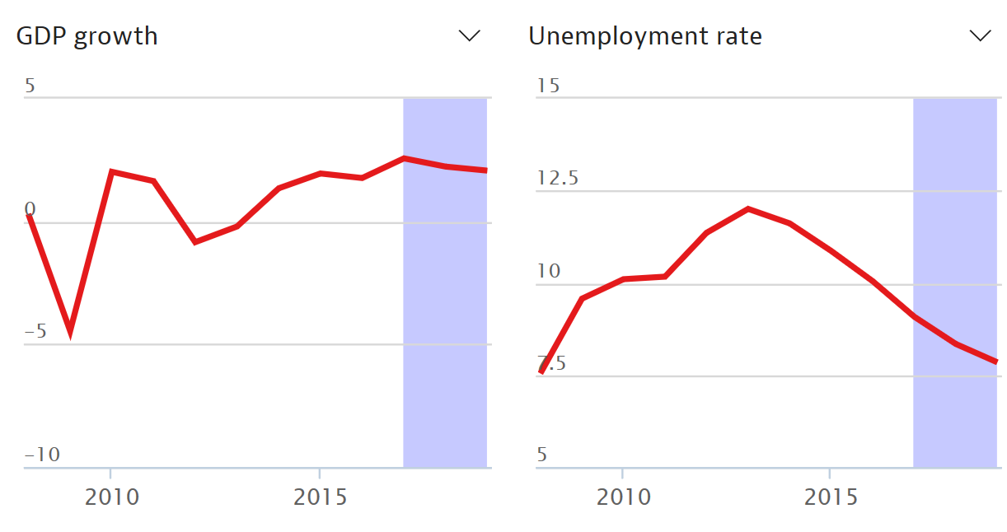
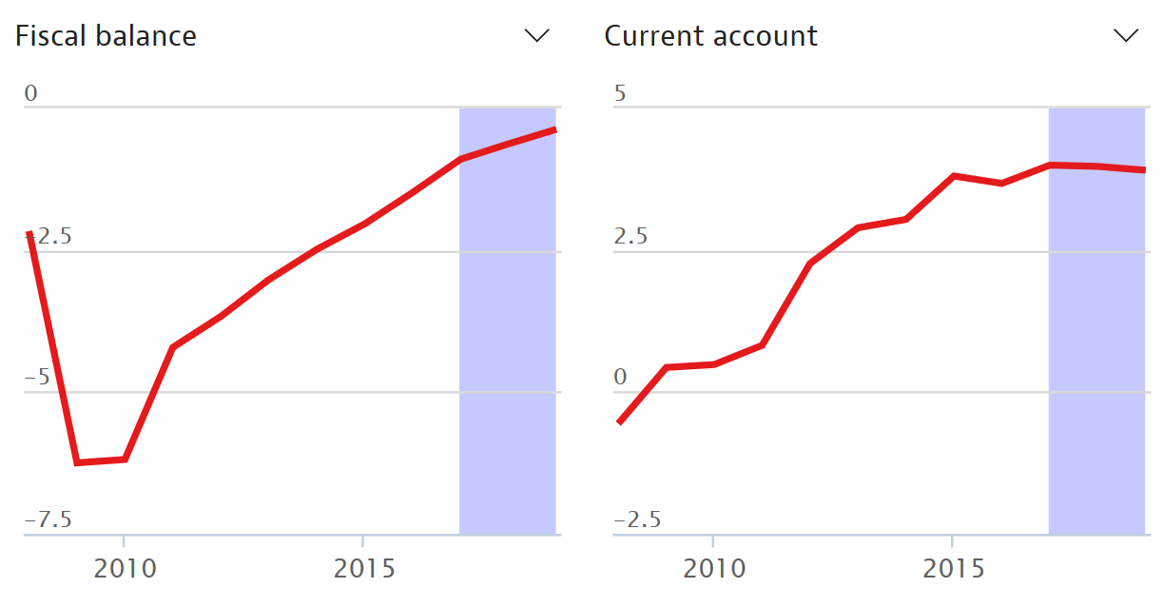

Source: OECD Economic Outlook (May 2018)
Note: Fiscal balance is the difference between government revenues and expenditures.

Question 1
 |  | Page 2/2 | Points
a) | Using the charts above, describe how the euro area’s economy has developed between 2008 and 2017. |  | 6 points
b) | With reference to the Gross Domestic Product (GDP) chart above, describe the four main phases of a trade cycle. |  | 7 points
c) | Explain the effects of the accelerator and multiplier in the trade cycle. |  | 10 points
d) | Discuss the effectiveness of counter-cyclical fiscal policies in stabilising the economy. |  | 10 points

Question 2
 |  | Page 1/2 | Points
Youth unemployment rates in Europe (July 2018)
Suède = Sweden
Finlande = Finland
Estonie = Estonia
Lettonie = Latvia
Lithuanie = Lithuania
Danemark = Denmark
Irlande = Ireland
Royaume-Uni = United Kingdom
Pays-Bas = Netherlands
Belgique = Belgium
Allemagne = Germany
Pologne = Poland
République tchèque = Czechia (Czech Republic)
Slovaquie = Slovakia
Autriche = Austria
Hongrie = Hungary
Luxembourg = Luxembourg
France = France
Portugal = Portugal
Espagne = Spain
Italie = Italy
Slovénie = Slovenia
Croatie = Croatia
Roumanie = Romania
Bulgarie = Bulgaria
Grèce = Greece
Malte = Malta
Chypre = Cyprus

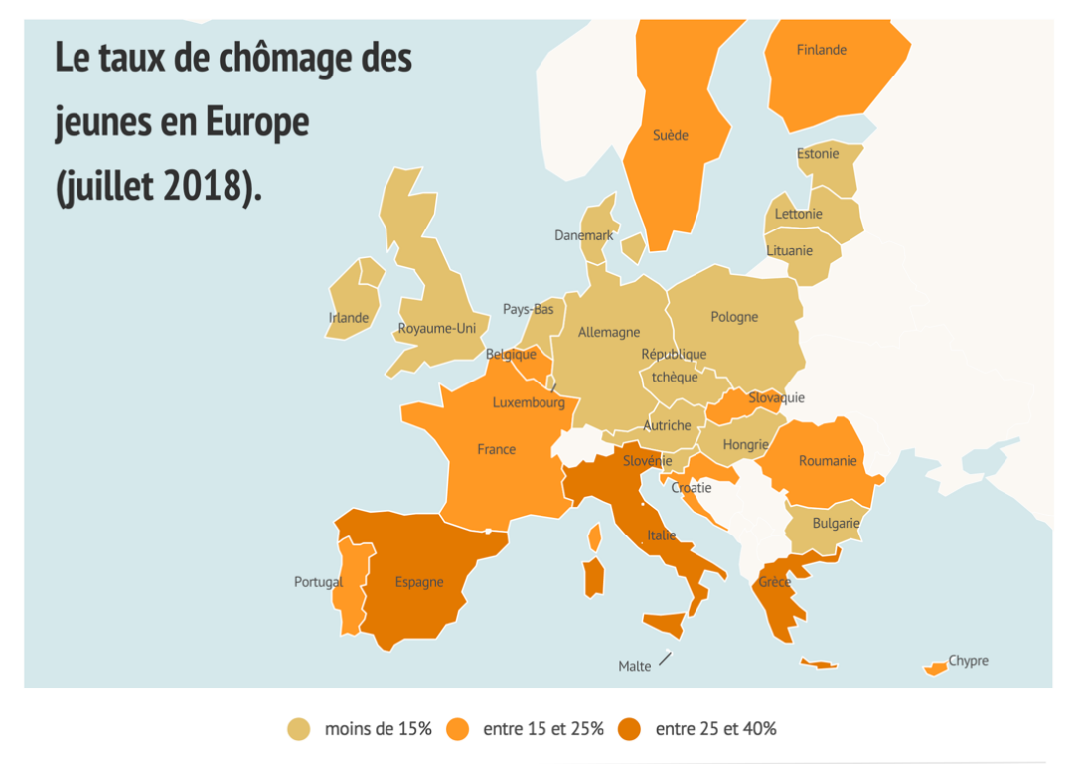
Moins de 15% = Less than 15%
Entre 15 et 25% = Between 15 and 25%
Entre 25 et 40% = Between 25 and 40%
 | Source : Toute l’Europe, Eurostat 2018
a) | Using the map above, describe the situation of youth unemployment in Europe and explain why rates differ in two countries of your choice. |  | 6 points
b) | Describe in detail two ways of measuring unemployment. |  | 7 points

Question 2
 |  | Page 2/2 | Points
c) | Explain the economic and social consequences of unemployment in the European Union. |  | 10 points
d) | Describe two demand-side measures and two supply-side measures that could be introduced to reduce unemployment in the European Union. Assess their effectiveness and limits. |  | 10 points

Question 3
 |  | Page 1/1 | Points
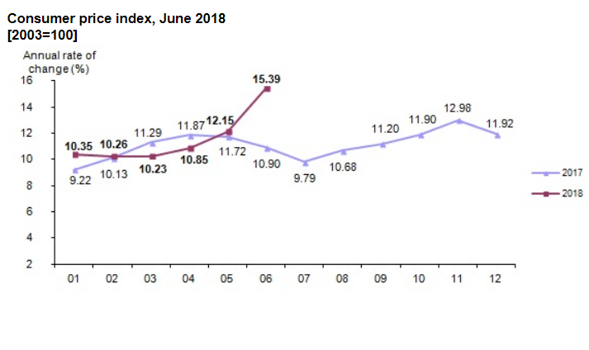
The official statistics for inflation in Turkey showed an increase in consumer prices compared on a yearly basis rising from 12.15% in May to 15.39% in June. (Remarkable!) That is the highest it has been since 2003. At the same time the current Producer Price Index in June was 23.71% after being 20.16% in May.

 | Source: Finanzmarktwelt, 3rd July 2018.
a) | With reference to the data above, describe and interpret the recent trend in inflation in Turkey. |  | 7 points
b) | Describe how inflation is measured and explain what role it plays in determining the strength of an economy. |  | 7 points
c) | Explain how monetary policy can be used to achieve an optimum inflation rate and other economic objectives. |  | 10 points
d) | “Deflation is a modern-day evil.” Discuss. |  | 10 points

EUROPEAN BACCALAUREATE 20XX

ECONOMICS

Proposed Solutions and Marking scheme

This marking scheme was created by the experts for the correctors. The experts have tried to be as comprehensive as possible and offer a guide to how points within a question must be allocated (pass mark and higher marks). However, capabilities and knowledge can be expressed in many ways and this should be taken into account by each corrector.

SUGGESTED SOLUTION AND GUIDELINES FOR EVALUATION: QUESTION 1
- Using the charts above, describe how the euro area’s economy has developed between 2008 and 2017. (6 points)
The effect of the financial crisis at the start of the period can be clearly seen in the negative GDP growth 2008-2010, rise in unemployment until 2013 and large increases in governments’ fiscal balances (deficits), which took until 2015 to return to 2008 levels of about 2.5% of GDP. It may seem strange that Current Accounts improved from about a 1% deficit in 2008 to a 2.5% surplus by 2012, but this is probably due to countries suffering from austerity importing less and within the euro area there will still be states with significant BoP Current Account deficits.
Since about 2012 economic circumstances in the euro area have been slowly improving. Assuming the forecasts are accurate, growth has averaged around 2% (about the long-term trend) since 2014 and in 2019 unemployment will drop back to more or less where it was before the crisis, though many would argue this is still too high. Fiscal balances are approaching balance, stronger than they have been for a long time; there will be large national variations within the €area and austerity has had a detrimental effect on many people in the countries that have suffered the largest deficits. The current account balance has stabilized at a surplus of around a 3% of GDP for 5 years which indicates a strong trading position for the €zone.
Marking recommendation:
To pass, candidates should briefly but clearly show they understand the indicators in at least three of the charts and describe the trends correctly.
Higher marks can be awarded as the level of detail, accuracy, and the explanation of the causes and implications of the trends, are given.
For example, good students will know that there are large differences between individual member states’ economies.

- With reference to the Gross Domestic Product (GDP) growth chart above, describe the four main phases of a trade cycle. (7 points)
The four main phases are:
- Peak or boom is characterised by high levels of national income after several years of growth. The economy works beyond its long-term trend level of output and unemployment is low (lower than the natural rate of unemployment). Students can point out that unemployment levels were low in 2008, just before the financial crisis. Inflation may well be above its target figure.

- Downturn or recession is characterised by weakening demand in the economy. During a recession, output falls and growth rates turn negative. The charts show that the euro area was in a recession in 2008-10 and again in 2012-13. Unemployment rates rose and fiscal balance deteriorated.
- Trough or slump follows a prolonged period of weak growth or recession, the economy reaches the bottom of the trade cycle. This is usually characterised by high unemployment and low levels of consumption and investment. The level of economic activity is low and so is inflationary pressure. The unemployment figures could indicate that the bottom of the cycle of the period shown was 2013.
- Recovery or expansion: during a recovery or expansion phase, the economy will experience a period of increasing national income and output levels. Unemployment will fall and wage pressures rise, causing inflation pressures to intensify. The period since 2013 can be seen as a period of recovery. GDP is growing steadily, albeit slowly, unemployment rates are falling, and the fiscal balance is improving.

Marking recommendation:
To pass, candidates have to name all four phases.
Higher marks for detail and explanation.

- Explain the effects of the accelerator and multiplier in the trade cycle. (10 points)

The accelerator theory of investment says that investment is a function of past changes in output and income. If household disposable income grows, so too does Aggregate Demand (AD) which will encourage greater investment. In the short term the increase in investment may be more than proportional; i.e. to increase output by 10% may require 25% increase in investment. According to this theory, the capital:output ratio is constant.

The increase in investment will, in turn, lead to an increase in national output and income via the multiplier effect and a further increase in AD; an injection of €10m through investment (or government spending or exports) may increase National Income by €20m – a multiplier of 2. Any shock to the economy, leading to higher demand and output and income levels, will set this multiplier process in motion. Hence the economy will continue to grow. On the other hand, in the event of a negative shock to demand and output levels, investment will fall leading to, via the multiplier process, a further fall in output and income.
Marking recommendation:
To pass, candidates should show an understanding of both principles and the role they play in the trade cycle. Case studies from real life and simple hypothetical examples should be rewarded.

- Discuss the effectiveness of counter-cyclical fiscal policies in stabilising the economy. (10 points)

Discretionary fiscal policy is the deliberate manipulation of government expenditure and taxes to influence Aggregate Demand in the economy. The government will try to increase AD during recessions and to restrain AD during periods of boom.

Automatic stabilisers are mechanisms which reduce the impact of changes in the economy on national income. These built-in stabilisers, without specific new legislation, increase/decrease budget deficits during periods of recession/booms. For example, social security schemes such as unemployment benefits provide income to more people as unemployment increases during periods of economic downturn or recession. At the same time, the taxes that contribute to such social security schemes also go down as income and expenditure decrease. These two effects cause the government budget deficit to increase automatically. Conversely, during boom periods these factors automatically produce surpluses or reduce deficits, as fewer benefits are paid as unemployment falls and tax revenues increase from more employment and spending.
There are many challenges and limitations to the way in which fiscal policy can manipulate AD. One of the main challenges faced by many European countries today is high debt levels and constraints set out in the Stability and Growth Pact. This has in turn led to high borrowing costs in many countries, contributing to ‘crowding out’. In addition to this, issues are the more general challenges of using fiscal policy; time lags and lack of accurate economic data, as well as imperfect forecasting of trends, all of which can lead to ill-timed fiscal stimulus or contraction.

Marking recommendation:
To pass, candidates have to be aware of fiscal and monetary policies and their impact on the economy.
Higher marks are awarded for discussion of policies’ effects and limitations.

Skills Matrix
QUESTION | KNOWLEDGE | COMPREHENSION | APPLICATION | ANALYSIS/  DISCUSSION | TOTAL
Q1a) | 1 | 2 | 3 |  | 6
Q1b) | 7 |  |  |  | 7
Q1c) |  | 5 | 5 |  | 10
Q1d) | 3 |  |  | 7 | 10
Sub-Total | 11 | 7 | 8 | 7 | 33

Original language: English

SUGGESTED SOLUTION AND GUIDELINES FOR EVALUATION: QUESTION 2
- Using the map above, describe the situation of youth unemployment in the European Union and explain why rates differ in two countries of your choice. (6 points)

Youth unemployment is relatively high across Europe though the graph shows strong disparities between European countries, with lower rates below 15% and the higher ones above 25%. The 16 countries with less than 15% include most of central Europe, the Baltic states, the UK and Ireland, as well as Bulgaria, Luxembourg, Netherlands and Denmark. In the medium range (15-25%) there are 9 countries: Portugal, France, Belgium, Romania, Croatia, Slovakia, Sweden, Finland and Cyprus. High (25%+) rates are observed in Spain, Italy and Greece.

Many would attribute the cause of the variation in rates to differences in labour market flexibility; countries with more rigid labour markets make it harder to ‘hire and fire’ and discourage the taking on of younger workers. High minimum wages and employment related costs (e.g. tax contributions) might make young workers too costly. There may also be a problem with young workers having inappropriate skills for employers’ needs. We can see that youth unemployment is highest in Italy, Spain and Greece, all states which suffered in the 2008 debt crisis and that have been subject to severe austerity measures. Other countries that suffered severe austerity measures, such as Ireland and Portugal, have recovered much better. Rates are lowest in countries which have experienced reasonable growth and development in recent years.

Marking recommendation:
In order to pass, candidates must recognise youth unemployment rates vary across the EU and point to geographical differences.
For higher marks, candidates may choose any two countries to compare, they are not expected to have detailed knowledge of the labour market in those countries but should be aware of some of the general causes of youth unemployment as outlined above.

- Describe in detail two ways of measuring unemployment. (7 points)

There are two main ways to measure unemployment. One follows the criteria adopted by the International Labour Organisation (ILO): to be unemployed, a person of working age must be without a paid job during the reference period, be available for work in the next two weeks, and to have actively sought work in the past four weeks. The other measure is the claimant count: it quantifies the number of individuals officially registered as unemployed and claiming benefits. The ILO is a survey and tends to underestimate unemployment since partial unemployment and discouraged job seekers are not considered unemployed according to this definition. On the other hand, a person who registers as unemployed but does not qualify for benefits will not be picked up by some claimant count measures. Workers’ organisations suggest ‘true’ unemployment is 2-3% higher than official figures, based on those who would like full time employment if they could get it.
Marking recommendation
Candidates who offer only one way of measuring should not pass.
Points to those who offer two ways of measuring will depend upon the amount of detail given.

- Explain the economic and social consequences of unemployment in the European Union. (10 points)

Persistently high unemployment has huge costs for individuals as well as for the economy as a whole. Additional social costs are also important, even if they are more difficult to measure. Students are expected to list some of the following points, but full credit can be given to answers that do not present all the elements in the non-exhaustive list below.
Excellent answers will distinguish between effects on individuals and those with an impact on the economy and society as a whole. Good students should point out the spiraling effect of unemployment, which leads to long term damage to the economy and an increase in poverty rates and various social costs (just a few of these are acceptable). Credit should be given when candidates link this aspect to measurable indicators (e.g. growth, poverty rates) but it is not necessary to achieve full points for this question.
- Loss of income: unemployment results in loss of income, a decline in spending power and the rise of debt problems as well as lower standards of living.
- Negative multiplier effect: loss in demand, and downward pressure on wages and house prices, which results in less consumption, further degrading unemployment.
- Loss of national output: GDP is below potential output if significant numbers of individuals are outside the labour market, damaging the economy’s growth potential. This hysteresis effect can have a deflationary effect on prices, profits and output.
- Fiscal costs: a fall in tax revenue and higher spending on welfare payments create tension on government budgets. As a response, governments will tend to reduce their spending to avoid growing budget deficits, or raise taxation, which means less public and merit goods and ultimately less growth.
- Social costs: high unemployment leads to social deprivation, the social stigma of being unemployed, worsening health and widening of income inequality. This is in turn linked to rising social dislocation, as evidenced in higher divorce rates for unemployed individuals or the political rise of extremist and populist parties. In the 1930’s, the rise of totalitarian regimes was linked to record high unemployment rates and to the promises of their leaders to deliver full employment.

Marking recommendation
Candidates should be aware of the fact that unemployment has costs for individuals, the wider economy, society and the government finances.
Higher marks should be awarded for detail and examples.

- Describe two demand-side measures and two supply-side measures that could be introduced to reduce unemployment in the European Union. Assess their effectiveness and limits. (10 points)

Analysis of Keynesian demand-oriented solutions should be referred to with an explanation of two looser fiscal or monetary measures that may be employed. An analysis of their effectiveness and limits (such as multiplier effect, reduced autonomy for eurozone members, increased budget deficit, liquidity trap among others) should be provided.
Two separate supply-side measures should be addressed too, examples could include:
- more flexibility in the labour market
- increasing the gap between minimum employed income and unemployment benefits to reduce the “inactivity trap”
- spending on education and welfare.

Marking recommendation
To pass, candidates should name two demand-side measures and two supply-side measures and describe them briefly.
Higher marks are awarded for assessing effectiveness and limitations.
Very good candidates can refer to the risk of worker exploitation such as the UK’s “zero-hour contract”, increased part-time working, in-work poverty. Excellent students should consider long term measures such as investment in general education, specific skills training and government incentives for business to employ staff; also encouraging greater labour flexibility and entrepreneurship amongst the young. Other relevant policy aimed at youth unemployment should be rewarded. Government spending on infrastructure could be accepted both as a demand side, with a multiplier effect, or as supply side by improving productive structures and efficiency.

Skills Matrix
QUESTION | KNOWLEDGE | COMPREHENSION | APPLICATION | ANALYSIS/  DISCUSSION | TOTAL
Q2a) |  | 3 | 3 |  | 6
Q2b) | 7 |  |  |  | 7
Q2c) |  | 5 | 5 |  | 10
Q2d) | 4 |  |  | 6 | 10
Sub-Total | 11 | 8 | 8 | 6 | 33

Original language: English

SUGGESTED SOLUTION AND GUIDELINES FOR EVALUATION: QUESTION 3
- With reference to the data above, describe and interpret the recent trend in inflation in Turkey. (7 points)
Marking recommendation
This is a question worth two points so ideally a reasonable answer will make at least two observations which are supported by actual data taken from the source material. Candidates that simply turn the numerical data into text should be given a marginal pass at best, the question states ‘describe’ and ‘interpret’ the impact of inflation at rates above 10% (and rising); doing so for the wider economy and its population is an important part of this question.

- Describe how inflation is measured and explain what role it plays in determining the strength of an economy. (7 points)

A possible answer could include the following, a definition of either:

- Consumer Price Index (CPI)
- Harmonised Index of Consumer Prices (HICP).

Inflation is important in determining the strength of an economy, because if it is too high, it will undermine confidence, cause higher interest rates, make government borrowing more costly, distort expectations, lead to higher wages, etc.. As a result, potential growth will be adversely affected.

Marking recommendation
To pass, candidates must know how to measure inflation using an index and describe it in some detail. Candidates must recognise the importance of weighting different categories of products and creating a system in which prices can easily be monitored and compared over time. If HICP is discussed, the importance of allowing international and inter-regional comparisons to be made should be mentioned.
For higher marks candidates should be aware that any inflation rate is only an ‘average’ and is not fully representative of all households; it is only as good as the sample size and the goods and services found within the ‘standard’ basket. It cannot represent the inflation rate experienced by all (or even most?) households precisely. There are difficulties with changes in the quality of goods; measures may also be slow to recognise changes in consumer expenditure patterns.
Good candidates should address the role of inflation in an economy.

- Explain how monetary policy can be used to achieve an optimum inflation rate and other economic objectives. (10 points)

The question can be tackled in numerous ways, but to be good the answer must include reference to and explanation of:

- a brief discussion of what the optimum inflation rate might be (usually about 2%) and why
- an explanation of the main instruments of monetary policy – interest rates, open market operations (OMO), quantitative easing (QE), reserve requirements

- an explanation of how various monetary policies impact on the economy e.g. lower interest rates should encourage consumer borrowing, business investment and maybe government borrowing, all of which should raise demand and increase growth, and thus higher inflation

The role of Central Banks and their ability to influence inflation, particularly when there are other macroeconomic issues to be addressed, will be considered by good candidates. The limits of monetary policy should be mentioned, particularly when interest rates have been very low for years, as at present.

Marking recommendation
To pass, candidates must define an optimum rate of inflation and briefly describe two instruments of monetary policy.
Good candidates might suggest that tighter monetary policies are necessary in Turkey and discussion of the way in which the inflation rate in Turkey might be reduced through them should be rewarded. Similarly, any attempt to provide case studies in monetary policy should be rewarded, if relevant.

- “Deflation is a modern-day evil.” Discuss. (10 points)

Having defined deflation, the student must explain many (but not all) of the possible consequences. They could also offset this with possible benefits of deflation, for example the potential increase in demand for exports.

Possible consequences could be (there is no need for the candidate to explain them all):

- Disruption to the real distribution of income
- Effects on confidence in the economy, particularly consumption and savings
- The real value of debt
- The impact of expectations of lower prices and their effect on demand
- Real interest rates rising
- Reduced revenue and profits, the possible bankruptcy of businesses
- Lack of confidence in a government and policy makers, and the knock-on effect that can have

Marking recommendation
To pass, candidates must define deflation and present three possible consequences.
Candidates have been instructed to ‘discuss’ the proposition; good and very good students should consider it from various perspectives and reach a rational conclusion based on their discussion.

Skills matrix

QUESTION | KNOWLEDGE | COMPREHENSION | APPLICATION | ANALYSIS/ DISCUSSION | TOTAL
Q3a) |  | 7 |  |  | 7
Q3b) | 3 | 2 | 2 |  | 7
Q3c) | 3 |  | 7 |  | 10
Q3d) | 1 |  |  | 9 | 10
Sub-total | 7 | 9 | 9 | 9 | 34
Original language: English

Paper Skills matrix

QUESTION | KNOWLEDGE | COMPREHENSION | APPLICATION | ANALYSIS/ DISCUSSION | TOTAL
Q1 | 11 | 7 | 8 | 7 | 33
Q2 | 11 | 8 | 8 | 6 | 33
Q3 | 7 | 9 | 9 | 9 | 34
Total | 29 | 24 | 25 | 22 | 100

