CONTENT
1. Generic Matrix Chemistry 2
2. Paper-specific Matrix 3
3. Sample Bac written examinations 4
4. Marking scheme 16

1. Generic Matrix Chemistry

Question | competence | Weight in % | Weight in points
Question A1  inorganic chemistry | Knowledge and Comprehension | 25 | 5-8
 | Application | 50 | 10-15
 | Analysis and Evaluation | 25 | 5-8
 | Total A1 |  | 25
Question A2  inorganic chemistry | Knowledge and Comprehension | 25 | 5-8
 | Application | 50 | 10-15
 | Analysis and Evaluation | 25 | 5-8
 | Total A2 |  | 25
Question B1  organic chemistry | Knowledge and Comprehension | 25 | 5-8
 | Application | 50 | 10-15
 | Analysis and Evaluation | 25 | 5-8
 | Total B1 |  | 25
Question B2  organic chemistry | Knowledge and Comprehension | 25 | 5-8
 | Application | 50 | 10-15
 | Analysis and Evaluation | 25 | 5-8
 | Total B2 |  | 25
Total exam |  |  | 100

2. Paper-specific Matrix

Question | competence | Weight in % | Weight in points
Question A1  inorganic chemistry | Knowledge and Comprehension | 28 | 7
 | Application | 52 | 13
 | Analysis and Evaluation | 20 | 5
 | Total A1 |  | 25
Question A2  inorganic chemistry | Knowledge and Comprehension | 24 | 6
 | Application | 55 | 13
 | Analysis and Evaluation | 24 | 6
 | Total A2 |  | 25
Question B1  organic chemistry | Knowledge and Comprehension | 24 | 6
 | Application | 48 | 12
 | Analysis and Evaluation | 28 | 7
 | Total B1 |  | 25
Question B2  organic chemistry | Knowledge and Comprehension | 24 | 6
 | Application | 52 | 13
 | Analysis and Evaluation | 24 | 6
 | Total B2 |  | 25
Total exam |  |  | 100

3. Sample Bac written examinations

CHEMISTRY

DATE: 2 June 2020

DURATION OF EXAMINATION:
3 hours (180 minutes)

PERMITTED EQUIPMENT:
Calculator: TI-Nspire in ‘Press-to-Test’ mode

INSTRUCTIONS:
- Answer both A questions and both B questions
- Use a different page for each of the four questions
- All relative atomic mass values are given in the periodic table of the elements provided. These values are the same as the molar mass values in g mol–1.

Question A1
Page 1/3 |  |  | Marks
a) | Lactic acid, C3H6O3, is a monoprotic “Brønsted acid”. When exercising, lactic acid can be produced in the muscles.  If a concentration of 3.00 x 10^{–3} mol dm^{–3} (mol L^{–1}) is reached in one’s blood, the muscles can hurt and cramp. It is suggested that drinking a lot of water helps to reduce the high concentration of lactic acid in the body.  Given: Ka for lactic acid
 | i. | Define the term “Brønsted acid”. | 1 mark
 | ii. | Give the formula of the conjugate base of the lactic acid molecule. | 1 mark
 | iii. | Write the equation for the reaction of lactic acid with water. | 1 mark
 | iv. | Write the expression for the acid ionisation constant, Ka, of a generic acid AH. | 1 mark
 | After intense training an athlete’s blood was analysed. The lactic acid mass concentration was 1.85 x 10–1 g dm–3 (g L–1).
 | v. | Justify by calculation that the athlete drank enough water to avoid cramps caused by lactic acid. | 2 marks
 | More concentrated aqueous solutions of lactic acid are used in a research project.
 | vi. | State the mathematical formula used to calculate the [H⁺] of a weak acid. | 1 mark
 | vii. | Calculate the pH of a solution of lactic acid with an initial concentration of 1.00 x 10–1 mol dm–3 (mol L–1) at 25°C. | 2 marks
 | Given: K_{a}(C₃H₆O₃(aq)) = 1.38 x 10^{–4} at 25°C
Question A1
Page 2/3 |  |  | Marks
b) | The molar concentration of lactic acid in a sample of volume 25.0 cm3 (mL) was determined using titration with a 5.00 x 10–2 mol dm–3 (mol L–1) aqueous solution of sodium hydroxide, NaOH(aq).  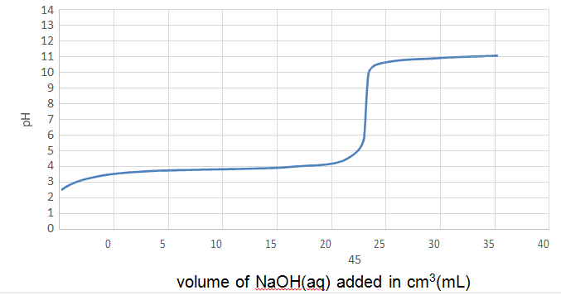  volume of NaOH(aq) added in cm3(mL)
 | i. | Write the equation for this titration reaction. | 1 mark
 | ii. | State two features of the titration curve of a weak acid. | 1 mark
 | iii. | Using the titration curve above, find the pH value at the equivalence point for this titration. | 1 mark
 | iv. | Show by calculation, using the equivalence point, that the initial molar concentration of the lactic acid was approximately  5.6 x 10–2 mol dm–3 (mol L–1). | 2 marks
 | v. | Show by calculation and with reference to the initial pH value of the lactic acid sample from the titration curve, that lactic acid is not a strong acid. | 3 marks
 | vi. | Determine the pKa of lactic acid from the titration curve. Justify your answer using the Ka expression. | 2 marks
 | vii. | Define what is the pH range of colour change of an indicator. | 1 mark
 | viii. | Justify why phenolphthalein is the most suitable indicator for this titration.  Indicator pH range of colour change  Crystal violet 0.0 – 1.8  Methyl orange 3.1 – 4.4  Phenolphthalein 8.2 – 10.0 | 2 marks
Question A1
Page 3/3 |  |  | Marks
c) | Human blood normally has a pH value of 7.4 at 37 oC. This value is kept constant by a buffer solution which contains, amongst other species, carbonic acid, H₂CO₃(aq), and the hydrogen carbonate ion, HCO −₃(aq).
 | i. | Explain how this buffer system works. Include in your answer two relevant equations. | 3 marks
 | ii. | Assuming that carbonic acid is a monoprotic acid, calculate the ratio: [HC0−₃(aq)] at pH = 7.4 at 37 oC.  [H2C03(aq)] | 2 marks
 | Given: pKa(H2CO3(aq)) = 6.1 at 37 oC
Question A2
Page 1/2 |  |  | Marks
a) | An electrochemical cell was constructed using the couples:  I_{2 (aq)}, / I⁻_{(aq)} Eº = + 0.54 V  Fe³⁺ _{(aq)}, / Fe²⁺_{(aq)} Eº = + 0.77 V
 | i. | Write the oxidation half equation. | 1 mark
 | ii. | Write the reduction half equation. | 1 mark
 | iii. | Write the overall balanced equation when the cell is operating. | 1 mark
 | iv. | Calculate the emf that the cell would generate under standard conditions. | 1 mark
 | v. | Draw a clearly labeled diagram of the electrochemical cell. Indicate on your diagram the polarity of the electrodes, the direction of electron flow and of ion flow. | 4 marks
 | vi. | List what are ‘standard conditions’ as described in part (iv) above. | 2 marks
b) | Sodium nitrite, NaNO₂, and sodium nitrate, NaNO₃, are used to preserve meat.  In order to determine the quantity of sodium nitrite in a preservative, 5.00 g of the preservative were dissolved in water and the resulting solution reacted with a 3.00 x 10⁻¹ mol dm⁻³ solution of acidified potassium dichromate, K₂Cr₂O₇.  During the reaction, the Cr₂O₇²⁻(aq) ions are converted into Cr³⁺(aq) ions while the NO₂₋(aq) ions are converted into NO₃₋(aq) ions.  10.8 cm³ of the K₂Cr₂O₇ solution are required to react with all the sodium nitrite present in the sample.
 | i. | Write the half-equations for the reduction and oxidation processes. | 2 marks
 | ii. | Write the overall balanced equation for the reaction. | 2 marks
 | iii. | Show that the amount, in moles, of nitrite ions present in the initial solution equals … | 3 marks
Question A2
Page 2/2 |  |  | Marks
c) | Given the following standard electrode potentials at 25ºC:  K⁺ (aq) / K(s) Eº = - 2.92 V  H₂O(aq) / H₂(g), Eº = - 0.41 V  O₂ (g), / H₂O(aq) Eº = + 0.81 V  Br₂(aq) / Br⁻ (aq) Eº = + 1.07 V
 | i. | Write the chemical equations for the reactions occurring at the positive and negative electrode during the electrolysis of molten potassium bromide. | 2 marks
 | ii. | In an experiment, a current of 3.00 A was passed through molten potassium bromide for 30 minutes. Calculate the mass of product formed at the positive electrode.  Given: Faraday constant, F = 9.65 x 10⁴ C mol⁻¹ | 3 marks
 | iii. | State what species you would expect to be formed at each electrode during the electrolysis of an aqueous solution of potassium bromide. Justify your answer by referring to the electrode potentials given. | 3 marks
Question B1
Page 1/2 |  |  | Marks
Eucalyptus oil and aspirin are often used to treat the symptoms of the common cold.
Eucalyptus oil has anti-bacterial properties and contains a number of esters, one of which is 3-methylbutyl butanoate. This ester is formed from 3-methylbutan-1-ol and butanoic acid.
Aspirin has anti-inflammatory properties and contains the active ingredient acetylsalicylic acid which can be formed from salicylic acid.
The structural formulas of 3-methylbutyl butanoate, 3-methylbutan-1-ol, acetyl salicylic acid and salicylic acid are given below:
3-methylbutyl butanoate 3-methylbutan-1-ol
acetylsalicylic acid salicylic acid
a) | A student mixes 3-methylbutyl butanoate with water in the laboratory and observes the formation of two layers.
 | i. | Explain the observation. | 1 mark
 | ii. | Write the equation for the formation of 3-methylbutyl butanoate using structural formulas. | 2 marks
 | iii. | State and explain the effect of replacing concentrated sulfuric acid with dilute sulfuric acid in the reaction. | 2 marks
 | iv. | Describe the role of the sulfuric acid in the esterification reaction. | 1 mark
 | v. | Identify the compound which provides the oxygen labeled X on structure 1. | 1 mark
 | vi. | Explain one piece of experimental evidence for this mechanism. | 2 marks
b) | 3-methylbutan-1-ol is a primary alcohol.
 | i. | Draw and name the structural formula of a secondary alcohol and tertiary alcohol which are isomers of this primary alcohol. | 4 marks
 | ii. | ii. Identify the type of reaction which can be used to distinguish between the secondary and tertiary isomers in b) i. Justify your response. | 2 marks
Question B1
Page 2/2 |  |  | Marks
 | iii. | Give the balanced equation for the reaction in b) ii. | 2 marks
 | In the eucalyptus plant 3-methylbutan-1-ol can be converted to 3-methylbutanoic acid.
 | iv. | Give the structural formula of 3-methylbutanoic acid. | 1 mark
 | The pK_{a} value of butanoic acid is 4.82 and that of 3-methylbutanoic acid is 5.01.
 | v. | Explain the difference in these pK_{a} values and why this difference is relatively small. | 2 marks
 | Salicylic acid has a pK_{a} value of 2.97.
 | vi. | With reference to the structure of salicylic acid, explain, why the pK_{a} is much lower than that of butanoic acid and 3-methylbutanoic acid. | 2 marks
c) | Aspirin helps to prevent inflammation by reacting with the amino acid serine, HO-Ser₅₃₀, which is part of a particular protein, as shown below (the number 530 refers to the position of serine in the protein):
 | i. | Give the structural formula of the reaction product using O—Ser₅₃₀. | 1 mark
 | In the laboratory salicylic acid can be formed from the hydrolysis of acetylsalicylic acid.
 | ii. | Write the equation for the reaction using structural formulas. | 2 marks
Question B2
Page 1/4 |  |  | Marks
a) | Lysine and phenylalanine are essential amino acids for humans.  Glutamic acid and serine can be formed by human cell metabolism.  Tyrosine can be enzymatically formed from phenylalanine. Glycine can  be formed from serine. The structural formulas of the six amino acids are given below:
 | 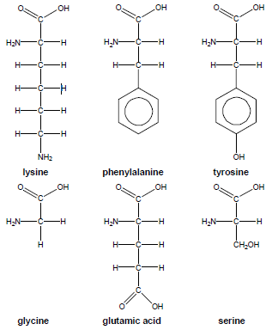
 | i. | Explain, which of the two amino acids lysine or phenylalanine you would expect to be the most water-soluble. | 2 marks
 | ii. | Copy the structural formula of tyrosine and circle all hydrogen atoms which could react with water in an acid-base-reaction. | 2 marks
 | iii. | Define the term isoelectric point of an amino acid. | 1 mark
Question B2
Page 2/4 |  |  | Marks
 | iv. | Give the structural formula of the predominant species of glycine at the isoelectric point. | 1 mark
 |  | The isoelectric point for serine is 5.68 at 25 °C.
 | v. | Give the structural formula of the predominant species of serine in an aqueous solution with a pH = 3.0. | 1 mark
Consider the following table:
Compound | Molar mass in g mol⁻¹ | Melting point in °C
Serine | 105 | 246
Hexan-1-ol | 102 | -45

 | vi. | Explain the significant difference in the melting points of the two given compounds. | 2 marks
 | Compound M can be formed when two of the amino acids given in question a) react with one another. The structural formula is:
 | vii. | Name the functional group linking the two amino acids. | 1 mark
 | viii. | Identify the two amino acids which reacted to form compound M. | 2 marks
 | Glycine and phenylalanine can react with one another to form two different dipeptides.
 | ix. | Give the structural formulas of both dipeptides. | 2 marks
Question B2
Page 3/4 |  |  | Marks
b) | During the last decades, several substances used as food dyes have been banned in Europe. The structural formula of one formerly used as a yellow dye is shown below:  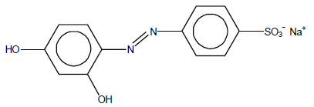
 | i. | Name the functional group linking the two aromatic rings. | 1 mark
 | ii. | Explain why this compound is coloured. | 2 marks
The dye above is hydrogenated under appropriate conditions. The structural formula of the product obtained is shown below:
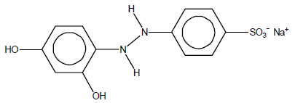
 | iii. | Give the common name of a long chain composed of amino acids. | 1 mark
 | iv. | Explain, whether the compound obtained can be used as a dye or not. | 1 mark
The yellow dye is produced from two aromatic Compounds A and B:
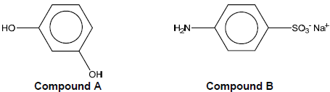
 | v. | Calculate the minimum mass of Compound A required to produce 1.00 x 10² g of the dye. | 3 marks
 | Given: Molar masses in g mol⁻¹: Compound A: 110, Compound B: 195
Question B2
Page 4/4 |  |  | Marks
c) | Kevlar, Poly(p-phenylene terephthalamide) is a very strong material used, for example, in puncture resistant tyres and bullet proof clothing. It is produced in a polycondensation reaction. The secondary product is hydrogen chloride, HCl.  Kevlar structure:
 | i. | By referring to the structure given above, explain the strength of Kevlar fibres. | 2 marks
 | The structural formula of one of the two monomers used to produce Kevlar is shown below:
 | ii. | Name the bond found between the two monomers in Kevlar. | 1 mark

4. Marking scheme

CHEMISTRY

DATE: 2 June 2020

ANSWERS AND MARK SCHEME

The following are the suggested answers together with the mark scheme for the correction of the papers. The answers are not necessarily 'model' answers. Where a candidate has given a correct alternative answer or used a different correct method to arrive at an answer full credit should be given.
The use of state symbols (i.e. (aq), (s), (l) and (g)) in the answers is optional. Accept either H⁺ or H₃O⁺ for a proton in water.
Numerical answers have been given to three significant figures.
A suggested breakdown showing the minimum needed for each marking point has been given.

Question A1 |  |  |  |  |  |  |  |  |  |  |  |  |  | COMPETENCES
Page 1/2 |  |  |  |  |  |  |  |  |  | Marks |  |  |  | KC | AP |  | AE
a) |  |  | i. |  |  |  | Proton donor [1] |  |  | 1 mark |  |  |  | 1
 |  |  | ii. |  |  |  | C₃H₅O₃¯(aq) [1] |  |  | 1 mark |  |  |  |  | 1
 |  |  | iii. |  |  |  | C₃H₆O₃(aq) + H₂O(l) C₃H₅O₃¯(aq) + H₃O₊(aq) [1] |  |  | 1 mark |  |  |  |  | 1
 |  |  | iv. |  |  |  | K_{a}(HX(aq)) = [X¯(aq)] x [H₃O⁺(aq)] / [HX(aq)] [1] |  |  | 1 mark |  |  |  | 1
 |  |  | v. |  |  |  | M(C₃H₆O₃) = 90.1 g mol^{–1} [1]  [C₃H₆O₃(aq)]  = 1.85 x 10^{–1} / 90.1 = 2.05 x 10^{–3} mol dm^{–3} (mol L^{–1}) [1]  ( [C₃H₆O₃(aq)] < 3.00 x 10^{–3} mol dm^{–3} (mol L^{–1}) so the athlete drank enough water. )  () not required |  |  | 2 marks |  |  |  |  |  |  |  | 2
 |  |  | vi. |  |  |  | [H₃O⁺(aq)] = (C_{a}K_{a})^{1/2} |  |  | 1 mark |  |  |  | 1
 |  |  | vii. |  |  |  | ( [C₃H₅O₃¯(aq)] = [H₃O⁺(aq)]  weak acid: [C₃H₆O₃(aq)] = 1.00 x 10^{–1} mol dm^{–3} (mol L^{–1}) )  [H₃O⁺(aq)]² = K_{a}(C₃H₆O₃(aq)) x [C₃H₆O₃(aq)]  [H₃O⁺(aq)] = (1.38 x 10^{–4} x 1.00 X 10^{–1})^{1/2} [1]  = 3.71 x 10^{–3} mol dm^{–3} (mol L^{–1})  pH = 2.43 [1]  () not required |  |  | 2 marks |  |  |  |  | 2
b) |  |  | i. |  |  |  |  |  | C₃H₆O₃(aq) + OH¯(aq) → C₃H₅O₃¯(aq) + H₂O(l) [1] | 1 mark |  |  |  |  | 1
 |  |  | ii. |  |  |  |  |  | presence of a buffer zone and pH at equivalence higher than 7 | 1 mark |  |  |  | 1
 |  |  | iii. |  |  |  |  |  | pH = 8.0 [1] (accept pH between 7.5 and 8.5) | 1 mark |  |  |  |  | 1
 |  |  | iv. |  |  |  |  |  | n(OH¯(aq)) = ( [OH¯(aq)] x V(OH¯(aq)) )  = 5.00 x 10⁻² x 28 x 10⁻³  = 1.4 x 10⁻³ mol = n(C₃H₆O₃(aq)) [1]  [C3H6O3(aq)] = ( n(C₃H₆O₃(aq)) / (C₃H₆O₃(aq)) )  = 1.4 x 10⁻³ / 25 x 10⁻³ [1]  = 5.6 x10⁻² mol dm⁻³ (mol L⁻¹) (given)  () not required | 2 marks |  |  |  |  | 2
 |  |  | v. |  |  |  |  |  | If C₃H₆O₃(aq) was a strong acid then the initial pH would be pH = -log (5.6 x10^{–2}) = 1.3 [1], but according to the graph, the initial value is pH = 2.6 > 1.3 [1] | 2 marks |  |  |  |  |  |  |  | 2
Question A1 |  |  |  |  |  |  |  |  |  |  |  |  |  | COMPETENCES
Page 2/2 |  |  |  |  |  |  |  |  |  | Marks |  |  |  | KC | AP |  | AE
 |  |  | vi. |  |  |  |  |  | K_{a}(C₃H₆O₃(aq)) = [C₃H₅O₃¯(aq)] x [H₃O⁺(aq)] / [C₃H₆O₃(aq)]  (answer to question a) v.)  ( so pH = pKa(C₃H₆O₃(aq)) + log( [C₃H₅O₃¯(aq)] / [C₃H₆O₃(aq)] ) )  At the half equivalence point of the titration curve the pH = 3.9 ± 0.2 and [C₃H₆O₃ (aq)] = [C₃H₅O₃¯(aq)] [1]  so pH = pK_{a}(C₃H₆O₃(aq)) (or K_{a}(C₃H₆O₃(aq)) = [H₃O⁺ (aq)]) [1]  () not required | 2 marks |  |  |  |  | 1 |  |  | 1
 |  |  | vii. |  |  |  |  |  | Accurate definition | 1 mark |  |  |  | 1
 |  |  | viii. |  |  |  |  |  | The pH range of colour change of phenolphthalein is on the steepest part of the titration curve [1] (or, accept also: … includes the pH at equivalence), so phenolphthalein is the most suitable indicator. [1] | 2 marks |  |  |  | 1 | 1
c) |  |  | i. |  |  |  |  |  | If the concentration of H3O+(aq) increases, the following reaction will take place:  HCO₃¯(aq) + H₃O+⁽aq) → H₂CO₃(aq) + H₂O(l)  If the concentration of OH¯(aq) increases, the following reaction will take place:  H₂CO₃(aq) + OH¯(aq) → HCO₃¯(aq) + H₂O(l)  Equations [1] + [1], explanation [1] | 2 marks |  |  |  | 1 | 1
 |  |  | ii. |  |  |  |  |  | pH = pK_{a}(H₂CO₃(aq)) + log( [HCO₃¯(aq)] / [H₂CO₃(aq)] ) [1]  so [HCO₃¯(aq)] / [H₂CO₃(aq)] = 10^{pH-} ^{pKa(H}₂^{CO}₃ ^{(aq))}  = 10^{7.4- 6.1} = 20 [1] | 2 marks |  |  |  |  | 2
Question A2 |  |  |  |  |  |  |  |  |  |  |  |  |  | COMPETENCES
Page 1/2 |  |  |  |  |  |  |  |  |  |  | Marks |  |  | KC |  | AP |  |  | AE
a) |  |  | i. |  |  |  | 2I–(aq) I₂(aq) + 2e– |  |  |  | 1 mark |  |  | 1
 |  |  | ii. |  |  |  | Fe³⁺(aq) + e– Fe²⁺(aq) |  |  |  | 1 mark |  |  | 1
 |  |  | iii. |  |  |  | 2I–(aq) + 2Fe³⁺(aq) I₂(aq) + 2Fe²⁺(aq) |  |  |  | 1 mark |  |  |  |  | 1
 |  |  | iv. |  |  |  | E.m.f. = +0.77 – 0.54 = +0.23V |  |  |  | 1 mark |  |  |  |  | 1
 |  |  | v. |  |  |  | 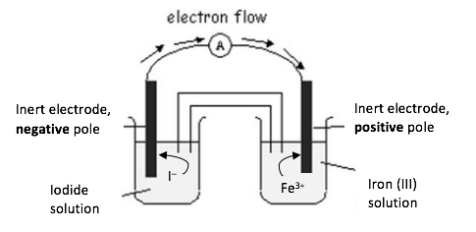 |  |  |  | 4 marks |  |  | 1 |  | 3
 |  |  |  |  |  |  | [Assign 1 mark Knowledge and Comprehension for the blank diagram, 1 mark Application for polarity of electrodes, 1 mark Application for direction of electrons, 1 mark Application for ion flow]
 |  |  | vi. |  |  |  | Concentration solutions of 1 mol dm^{–3} [1] , pressure of 1 atm (not required here), 25 ºC. [1] |  |  |  | 2 marks |  |  | 2
b) |  |  | i. |  |  |  |  | Oxidation: NO₂–(aq) + H₂O(l) NO₃–(aq) + 2H⁺(aq) + 2e– [1]  Reduction: Cr₂O₇^{2–}(aq) + 14H⁺(aq) + 6e^{– +} 2Cr³⁺(aq) + 7H₂O(l) [1] |  |  | 2 marks |  |  |  |  | 2
 |  |  | ii. |  |  |  |  | Cr₂O₇^{2–}(aq) + 3NO₂–(aq) + 8H⁺(aq) 2Cr³⁺(aq) + 3NO₃–(aq) + 4H₂O(l) [2] |  |  | 2 marks |  |  |  |  | 2
 |  |  | iii. |  |  |  |  | Mol Cr₂O₇^{2–} : 0.0108 dm^{–3} x 3.00 x 10⁻¹ mol dm⁻³ = 3.24 x 10^{–3} mol [1]  Mol NO₂– : 3.24 x 10^{–3} mol x 3 = 9.72 x 10^{–3} mol [1 mark Analysis/Evaluation, 1 mark Application] |  |  | 3 marks |  |  |  |  | 2 |  |  | 1
Question A2 |  |  |  |  |  |  |  |  |  |  |  |  |  | COMPETENCES
Page 2/2 |  |  |  |  |  |  |  |  |  |  | Marks |  |  | KC |  | AP |  |  | AE
c) |  |  |  | i. |  |  | K⁺(l) + e– K(l) [1 mark AE] |  |  |  | 1 mark |  |  |  |  |  |  |  | 1
 |  |  |  |  |  |  | 2Br – (l) Br₂(l) + 2e– [1] |  |  |  | 1 mark |  |  |  |  |  |  |  | 1
 |  |  |  | ii. |  |  | At the positive electrode, formation of Bromine.  $n_{e}= \frac{I ×t}{F}$ [1]  $n_{e}= \frac{3.00A×1800 s}{9.65×{10}^{4} {mol}^{-1}}=5.56×{10}^{-2}mol e^{-}$ [1]  Mass of Br₂: 5.56 x 10^{–2} x ½ x 159.8 = 4.47 g [1] |  |  |  | 3 marks |  | 1 |  |  | 2
 |  |  |  | iii. |  |  | You would expect the formation of O₂(g) at the anode, and the formation of H₂(g) at the cathode. [1]  The couple H₂O/H₂ has a less negative E_{red} than the K⁺ /K couple therefore it would be preferred. [1]  The oxidation of water to O₂(g) would be preferred over the oxidation of bromide ion as the couple Br₂/Br – has a more positive E_{red} than the O₂/H₂O couple. [1] |  |  |  | 3 marks |  |  |  |  |  |  |  | 3
Question B1 |  |  |  |  |  |  |  |  |  |  |  |  | COMPETENCES
Page 1/2 |  |  |  |  |  |  |  |  |  |  | Marks |  | KC |  |  | AP |  |  | AE
a) |  |  | i. |  |  |  |  | Due to the hydrophobic hydrocarbon chains, 3-methylbutylbutanoate is not miscible to water (or the ester is non-polar whereas water is polar) [1] |  |  | 1 mark |  |  |  |  |  |  |  | 1
 |  |  | ii. |  |  |  |  | Formula of butanoic acid [1]; Stoichiometry (water) [1] |  |  | 2 marks |  |  |  |  | 2
 |  |  | iii. |  |  |  |  | If concentrated H₂SO_{4(aq)} is replaced with diluted H₂SO_{4(aq)} the equilibrium is shifted towards the reactants [1]. This is explained by the Le Chatelier principle, related to the addition of H₂O (product). [1] |  |  | 2 marks |  |  |  |  | 1 |  |  | 1
 |  |  | iv. |  |  |  |  | H₂SO₄ catalyzes the reaction. [1] |  |  | 1 mark |  | 1
 |  |  | v. |  |  |  |  | 3-methylbutan-1-ol [1] |  |  | 1 mark |  | 1
 |  |  | vi. |  |  |  |  | By radiolabelling 3-methylbutanol with the ¹⁸O radioisotope. [1]. If after the reaction with butanoic acid the ¹⁸O radioisotope is detectable as the bridging oxygen in the ester 3-methylbutylbutanoate, this proves that the linking oxygen atom comes from the alcohol. If it is detectable in the water molecule after the reaction then the linking oxygen atom is derived from the butanoic acid. [1]  Or comparable reasoning with ¹⁸O in the HO- group [1] of the butanoic acid. |  |  | 2 marks |  | 1 |  |  |  |  |  | 1
b) |  |  | i. |  |  |  |  | 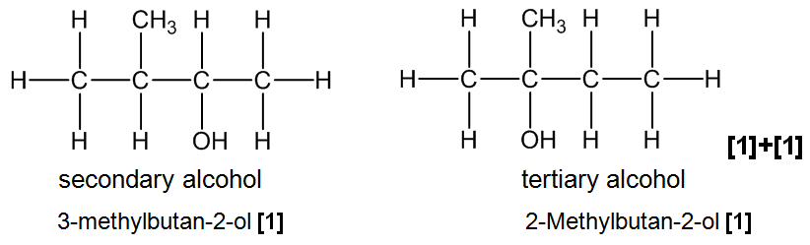 |  |  | 4 marks |  |  |  |  | 4
 |  | ii. |  |  |  |  | Oxidation [1] which is possible with the secondary alcohol but not the tertiary alcohol [1] |  |  |  | 2 marks |  | 2
 |  | iii. |  |  |  |  | Use of KMnO₄(aq) (or K₂Cr₂O₇) [1] Correct balanced reaction [1] |  |  |  | 2 marks |  | 1 |  |  | 1
Question B1 |  |  |  |  |  |  |  |  |  |  |  |  | COMPETENCES
Page 2/2 |  |  |  |  |  |  |  |  |  |  | Marks |  | KC |  |  | AP |  |  | AE
 |  | iv. |  |  |  |  | 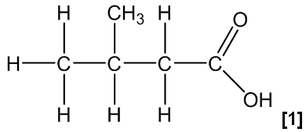 |  |  |  | 1 mark |  |  |  |  | 1
 |  | v. |  |  |  |  | The positive inductive effect of the methyl group in 3-methylbutanoic acid increases the electron density on the carboxyl group thus increasing the attraction of the proton. [1] Therefore 3-methylbutanoic acid is a weaker acid compared to butanoic acid.  However, the difference is relatively small because the methyl group is not close to the carboxyl group. [1] |  |  |  | 2 marks |  |  |  |  |  |  |  | 2
 |  | vi. |  |  |  |  | The delocalization of the pi electrons of the phenyl group (mesomeric effect) [1] decreases the electron density on the carboxyl group thus decreasing the attraction of the proton. [1] |  |  |  | 2 marks |  |  |  |  |  |  |  | 2
c) | i. |  |  |  | 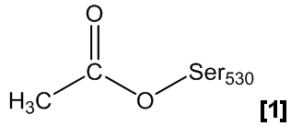 |  |  |  |  |  | 1 mark |  |  |  |  | 1
 | ii. |  |  |  | Salicylic acid [1] Ethanoic acid [1] |  |  |  |  |  | 2 marks |  |  |  |  | 2
Question B2 |  |  |  |  |  |  |  |  |  |  |  |  | COMPETENCES
Page 1/2 |  |  |  |  |  |  |  |  |  |  | Marks |  | KC |  |  | AP |  |  | AE
a) | i. |  |  |  | Lysine is the most water soluble as it does not contain a hydrophobic benzene ring [1] and it also contains an extra polar amino group [1]. |  |  |  |  |  | 2 marks |  |  |  |  |  |  |  | 2
 | ii. |  |  |  | 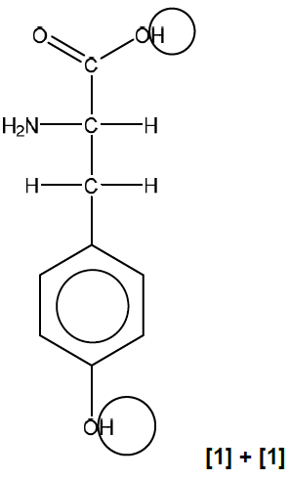 |  |  |  |  |  | 2 marks |  |  |  |  | 2
 | iii. |  |  |  | The isoelectric point is the pH of an aqueous solution at which the amino acid has a neutral charge [1] |  |  |  |  |  | 1 mark |  | 1
 | iv. |  |  |  | 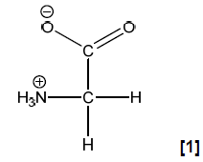 |  |  |  |  |  | 1 mark |  |  |  |  | 1
 | v. |  |  |  | 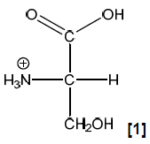 |  |  |  |  |  | 1 mark |  |  |  |  | 1
 | vi. |  |  |  | Serine: Strong ionic bonds (between the zwitterions) [1].  Hexan-1-ol: Weaker hydrogen bonds (and Van der Waal’s forces) [1].  () not required |  |  |  |  |  | 2 marks |  |  |  |  |  |  |  | 2
 | vii. |  |  |  |  | Ester linkage [1] |  |  |  |  | 1 mark |  | 1
 | viii. |  |  |  |  | Glutamic acid [1] and Serine [1] |  |  |  |  | 2 marks |  |  |  |  | 2
Question B2 |  |  |  |  |  |  |  |  |  |  |  |  | COMPETENCES
Page 2/2 |  |  |  |  |  |  |  |  |  |  | Marks |  | KC |  |  | AP |  |  | AE
 | ix. |  |  |  |  | 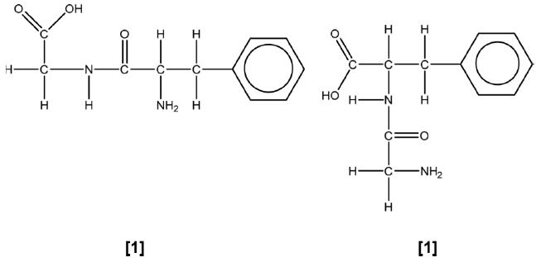 |  |  |  |  | 2 marks |  |  |  |  | 2
b) | i. |  |  |  |  | Azo group. [1] |  |  |  |  |  | 1 mark | 1
 | ii. |  |  |  |  | The molecule contains extensive conjugation or delocalisation of electrons across the double bonds and the two benzene rings, [1], which makes the absorption of light in the visible region possible. [1] |  |  |  |  |  | 2 marks | 1 |  |  | 1
 | iii. |  |  |  |  | Protein |  |  |  |  |  | 1 mark | 1
 | iv. |  |  |  |  | No, the hydrogenated molecule can’t be used as a dye because the delocalisation is not extended enough anymore. [1] (the double  bond between the two nitrogen atoms is now a single bond.)  () not required |  |  |  |  |  | 1 mark |  |  |  | 1
 | v. |  |  |  |  | (The calculation involves the calculation of the amount of dye,  which is identical to the amount of A required:) M(dye) = M(A) + M(B) + M(N) – 3 M(H)  = 110 +195 +14.0 –3.03 = 316 g mol^{–1} [1]  (From this amount, the mass of A can be calculated:)  m(A) = n(A) x M(A) = 0.316 x 110 = 34.8 g [1]  () not required |  |  |  |  |  | 3 marks |  |  |  | 3
c) | i. |  |  |  |  | The Poly(p-phenylene terephthalamide)-molecule contains hydrogen bonding between the chains [1]. Long chain molecules stiffened due to conjugation through benzene rings and amide links. [1]  Any correct explanation including the Phenyl group is to be accepted. |  |  |  |  | 2 marks |  |  |  |  |  |  |  | 2
 | ii. |  |  |  |  | Peptide bond [1] |  |  |  |  | 1 mark |  | 1

