**Generic Matrix for the Bac exam paper**

|  |  |  |  |  |  |
| --- | --- | --- | --- | --- | --- |
| **Task** | **Competence(s)** | **Objectives** | **Questions/Productions** | **Weight in %** | **Weight in points** |
|  |  | The student is able to … |  |  |  |
| Preparatory work | Preparatory studies | .. develop his/her ideas through rough sketches | Use the media of your choice to make rough sketches to depict your idea(s) | 30% |  |
| Skills and technique | … use a large repertoire of art elements, materials and techniques appropriately and skilfully in the realisation of his/her work | Apply different methods of design and composition by using the material(s) of your choice | 30% |  |
| Research | … show a structured and organized working process with clearly visible development | Record all the information you get from different sources (text, images, internet) | 20% |  |
| Presentation and organisation | … can select and present his/her work appropriately | Use a maximum of 3 sheets 50 X 70cm to present your preparatory work well organised | 20% |  |
| **40** |  |  |  |  |  |
| Final work | Interpretation/realisation | … to produce an original and appropriate composition by bringing his preparatory work to conclusion in a finished work | Create an original and sophisticated piece of work very well finished | 40% |  |
| Skills and technique | … to demonstrate his/her sensitivity to materials and art elements and to show outstanding skills in their use | Choose the appropriate media to bring your final work to a conclusion by showing your expertise on the material chosen | 40% |  |
| Presentation | … to give care to the organization and presentation of the final work | Present your final work by using the appropriate paper of presentation (passe-partout) | 20% |  |
| **50** |  |  |  |  |  |
| Final statement | Critical reflection | … to demonstrate a critical reflection on the making of the final work | Reflect in a short-written commentary on your development of the theme from your ideas, your preparatory work to your final work | 40% |  |
| Comprehension | … to show his/her understanding of the year theme in the context of the set exam task | Connect your work with the context of the year theme | 30% |  |
| Art historical awareness | … to make connections with the work of artists linked to the year theme | Refer to the artists that inspired you to the creation of your artwork | 30% |  |
| **10** |  |  |  |  |  |
| **Total 100** |  |  |  |  |  |

|  |  |  |  |  |  |  |
| --- | --- | --- | --- | --- | --- | --- |
| **EXCELLENT** | **VERY GOOD** | **GOOD** | **SATISFACTORY** | **SUFFICIENT** | **WEAK** | **VERY WEAK** |
| 100 – 90 | 89 – 80 | 79 – 70 | 69 – 60 | 59 – 50 | 49 – 30 | 29 – 0 |

**Paper specific matrix**

|  |  |  |  |  |  |
| --- | --- | --- | --- | --- | --- |
| **Task** | **Competence(s)** | **Objectives** | **Questions/Productions** | **Weight in %** | **Weight in points** |
|  |  | The student is able to … |  |  |  |
| Preparatory work | Preparatory studies | .. develop his/her ideas through rough sketches | Use the media of your choice to make rough sketches to depict your idea(s) | 30% | 12 |
| Skills and technique | … use a large repertoire of art elements, materials and techniques appropriately and skilfully in the realisation of his/her work | Apply different methods of design and composition by using the material(s) of your choice | 30% | 12 |
| Research | … show a structured and organized working process with clearly visible development | Record all the information you get from different sources (text, images, internet) | 20% | 8 |
| Presentation and organisation | … can select and present his/her work appropriately | Use a maximum of 3 sheets 50 X 70cm to present your preparatory work well organised | 20% | 8 |
|  |  |  |  | **100 %** | **40** |
| Final work | Interpretation/realisation | … to produce an original and appropriate composition by bringing his preparatory work to conclusion in a finished work | Create an original and sophisticated piece of work very well finished | 40% | 20 |
| Skills and technique | … to demonstrate his/her sensitivity to materials and art elements and to show outstanding skills in their use | Choose the appropriate media to bring your final work to a conclusion by showing your expertise on the material chosen | 40% | 20 |
| Presentation | … to give care to the organization and presentation of the final work | Present your final work by using the appropriate paper of presentation (passe-partout) | 20% | 10 |
|  |  |  |  | **100%** | **50** |
| Final statement | Critical reflection | … to demonstrate a critical reflection on the making of the final work | Reflect in a short-written commentary on your development of the theme from your ideas, your preparatory work to your final work | 40% | 4 |
| Comprehension | … to show his/her understanding of the year theme in the context of the set exam task | Connect your work with the context of the year theme | 30% | 3 |
| Art historical awareness | … to make connections with the work of artists linked to the year theme | Refer to the artists that inspired you to the creation of your artwork | 30% | 3 |
|  |  |  |  | **100%** | **10** |

|  |  |  |  |  |  |  |
| --- | --- | --- | --- | --- | --- | --- |
| **EXCELLENT** | **VERY GOOD** | **GOOD** | **SATISFACTORY** | **SUFFICIENT** | **WEAK** | **VERY WEAK** |
| 100 – 90 | 89 – 80 | 79 – 70 | 69 – 60 | 59 – 50 | 49 – 30 | 29 – 0 |

**Sample Bac exam paper**

**ART EDUCATION**

**ART EDUCATION**

|  |  |
| --- | --- |
| **DATE:** | 2020 |
| **LENGTH OF THE EXAMINATION:** | **Preparatory work** 4 lessons (180 minutes)  **Final work** 5 hours (300 minutes) |
| **PERMITTED EQUIPMENT:** | All materials and equipment normally available in the art room. |
| **SPECIAL REMARKS:** | The use of the Internet is only permitted during the preparation period. Only USB sticks provided by the school are allowed |

**Theme: “Empty places”**

*“There’s eyes behind the mirrors in empty places”, Bob Dylan*

**Introduction:**

When considering an artistic composition, it is natural to first attend to what is there; the figures, objects or landscapes which the artist has chosen to portray. However, there is often just as much meaning in what is absent; empty places can speak volumes.

Empty spaces in artwork are not simply an absence; they are their own content and carry their own meanings. By noticing the emptiness, the absences in the piece as well as what is present, you can see more of the whole.

The idea of place and space are broad terms within the practical and conceptual dimensions of art practice and study. Artists and scholars have labored to define the tangible and abstract dimensions of these concepts. Theories of place and space are thus viewed through numerous lenses; for example, *Gestalt Theory* explores the practical and formal elements of the organization of objects in space; French psychoanalyst Jacques Lacan considered psycho-social dimensions of place and space; and Gaston Bachelard’s *The Poetics of Space* contemplates the whimsical, melancholy and anthological aspects of place and space. Focusing on the sentimental qualities of place, Patricia Highsmith captures the imaginative power of abandoned space in her short story, *Black House*, where a derelict house on the outskirts of a small town becomes a spectral focal point for the villagers’ nostalgia and anxiety.

**Task:**

Create a work on the theme *Empty places*. Explore the visual and social significance of abandoned place – where derelict factories, churches, private houses or other empty places serve as the basis for creative investigation. Be inspired by the text, the given pictures and by your personal experience.

**1. Preparatory work (40%)**

Develop your personal ideas with sketches. Try different methods of design and composition, choosing those which support your ideas to a final work.

Develop the composition further, experimenting with different techniques, forms and colours.

(Sketches and studies showing the development of your solution, presented on a maximum of 3 sheets 50x70 cm or equivalent)

**2. Final work (50%)**

Bring your preparatory work to conclusion in a finished work.

(Final work minimum size 30x40 cm, maximum size 50x70 cm; three-dimensional works must not be larger than 50 x 50 x 70 cm)

**3. Written explanation (10%)**

Reflect in a short-written comment on the development of your ideas. Explain and justify your artistic choices.

**Pictures:**

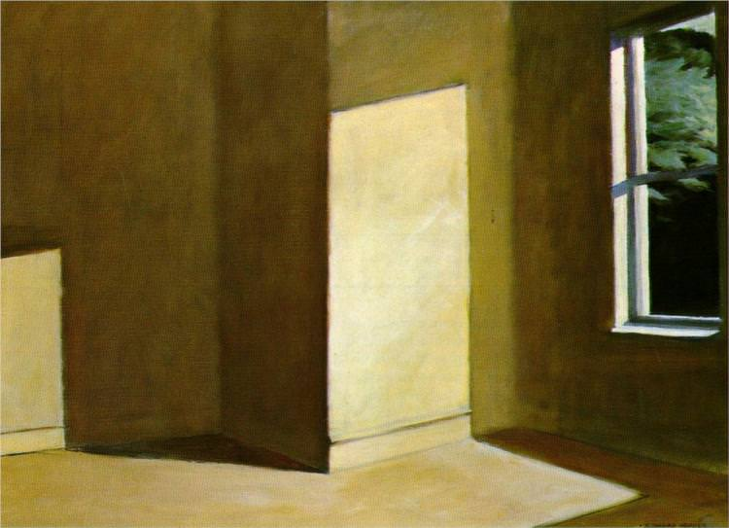

Edward Hopper

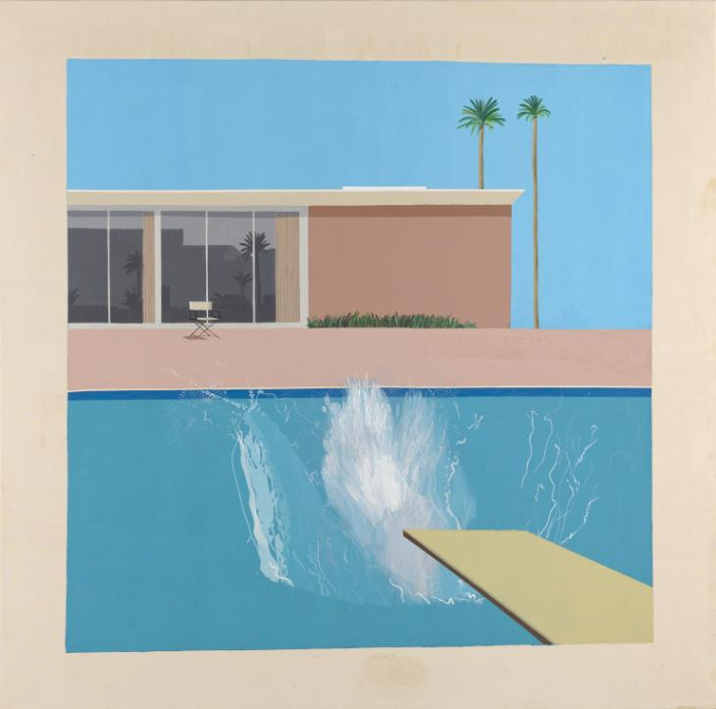

David Hockney

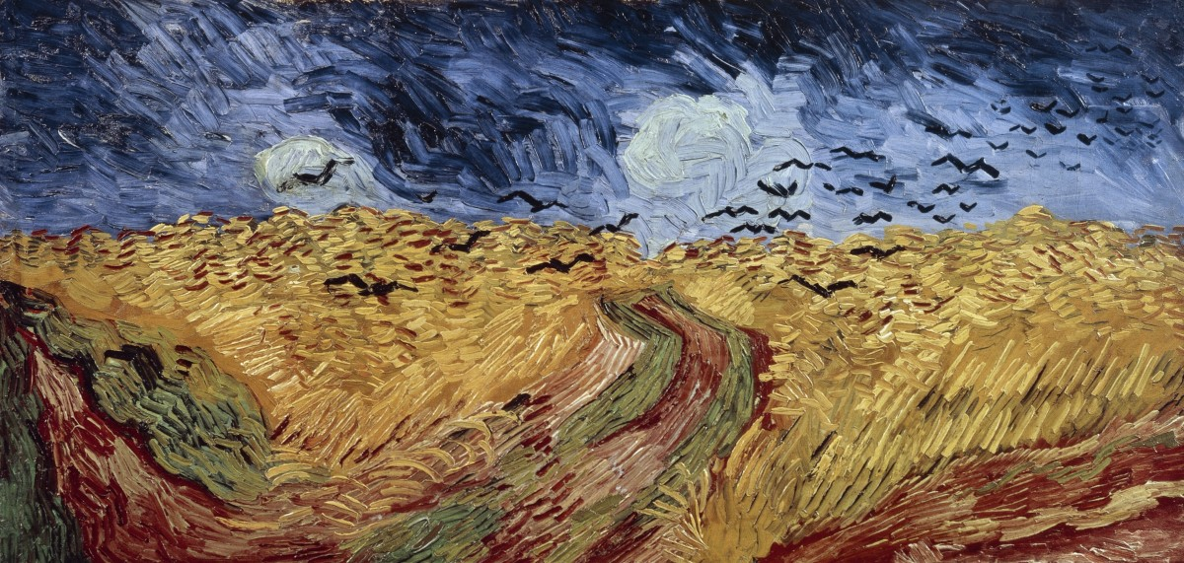

Vincent Van Gogh

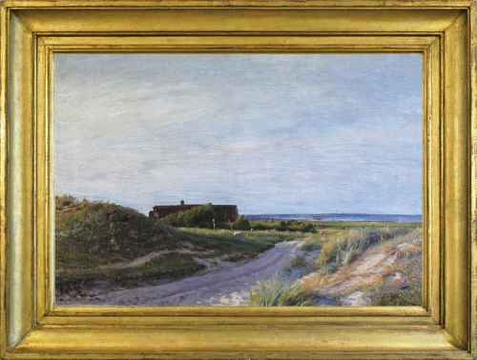

Sigvard Hansen

**Marking scheme – a rubric to evaluate the bac exam**

|  |  |  |  |  |  |  |  |
| --- | --- | --- | --- | --- | --- | --- | --- |
| **Question to be assessed** | ***Excellent***  ***A*** | ***Very good***  ***B*** | ***Good***  ***C*** | ***Satisfactory***  ***D*** | ***Sufficient***  ***E*** | ***Weak***  ***F*** | ***Very weak***  ***FX*** |
| **Preparatory work** | **40 – 36 p**  The student displays a highly coherent working process with a wide range of initial ideas modified and refined to arrive at an elaborated and excellently presented final piece of work. | **35 – 32 p**  The student displays a coherent working process with initial ideas modified and refined to arrive at an elaborated and well-presented final piece of work. | **31 – 28 p**  The student shows a working process from his/her initial ideas to a correctly presented final piece of work. | **27 – 24 p**  The student shows some development from his/her initial ideas to a final piece of work. | **23 – 20 p**  The student fairly shows a development from his/her initial ideas to a final piece of work. | **19 – 11 p**  No coherent development from initial ideas to a finished piece of work. | **10 – 0 p**  No coherent working process visible. |
| **Final work** | **50 – 45 p**  A highly original and sophisticated composition, showing excellent technical competence in the media chosen, highly creative interpretation of the task, well presented and complete. | **44 – 40 p**  A very good, original and appropriate composition, showing very good technical competence in the media chosen, a very good interpretation of the task, well presented and complete. | **39 – 35 p**  Good and adequate composition, showing good technical competence in the media chosen, a good interpretation of the task with care given to organization and presentation. | **34 – 30 p**  Correct interpretation of the task with a little evidence of composition, satisfactory level of technical skills, satisfactory level of presentation. | **29 – 25 p**  Superficial understanding of the task, some evidence of composition, poor technical competence in the media chosen, poor organization and presentation. | **24 – 15 p**  Incomplete, little originality, task was not or fully understood, little technical skill. | **14 – 0 p**  No final work was handed in or very incomplete. |
| **Final statement** | **10 – 9 p**  Highly personal reflection and critical appraisal of the final work, showing an excellent understanding of the year theme in the context of the set exam task. Relevant connections made with the work of artists linked to the year theme, showing excellent knowledge, a clear and structured concept. | **8,9 – 8 p**  A very good critical reflection on the final work, analysing the work process and the media chosen, showing a very good knowledge and understanding of the relevant aspects of artistic design and artists linked to the year theme, a clear and structured concept. | **7,9 – 7 p**  A good personal reflection on the final work, taking into account the relevant artistic processes and the work of artists linked to the year theme, a solid knowledge and understanding, an appropriate use of terminology. | **6,9 – 6 p**  Adequate reflection on the final work with a fairly complete understanding of the year theme in context to the set exam task. Some attempts to analyse the working process and the decision criteria, use of an appropriate vocabulary. | **5,9 – 5 p**  Some reflection on the final work with a basic understanding of the year theme in the context of the set exam task, limited knowledge and understanding of main aspects of the artistic design and the work of other artists, uncertainties in the use of an appropriate vocabulary. | **4,9 – 3 p**  Insufficient final statement, no coherence in the written commentary on the final work, poor knowledge and understanding of artistic aspects regarding design and the content of the year theme. | **2,9 – 0 p**  No final statement or irrelevant. |

|  |  |
| --- | --- |
| Points | Grades |
| 100 – 90 | A (Excellent) |
| 89 – 80 | B (Very good) |
| 79 – 70 | C (Good) |
| 69 – 60 | D (Satisfactory) |
| 59 – 50 | E (Sufficient) |
|  |  |
| 49 – 30 | F (Failed Weak) |
| 29 – 0 | FX (Failed Very Weak) |